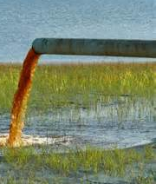
Name_________________________________ Period______
Water Pollution Lab

Purpose
- Model ground water pollution
- Map pollution using transects
- Create a story explaining the results in terms of point or nonpoint source pollution

Materials
- Landscape with pollution and grids
- Phenolphthalein (NaOH indicator)
- Well Plate
- Droppers
- Water

Safety Considerations
- Wear gloves and goggles when working with NaOH
- Phenolphthalein can stain fingers

Procedure: Find the water pollution source by mapping the area
- Take a sample from every square of your plot.
- Rinse the pipette with water between each sample
- Add a drop of phenolphthalein to each well
- Create a map of the relative concentration of sodium hydroxide in each square area of the plot (shade in to indicate darkness of pink)
- In your map indicate the most likely source(s) of the contamination

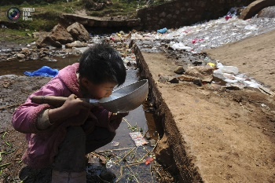

Data:
Shade in the map, indicating the relative level of contamination where the pollution was found:
 | 1 | 2 | 3 | 4
A
B
C
D

Conclusions: Write a story indicating the likely source or sources of water pollution in your “landscape” and whether it/they would be considered Point-source pollution or Non-point source pollution. Be creative!

