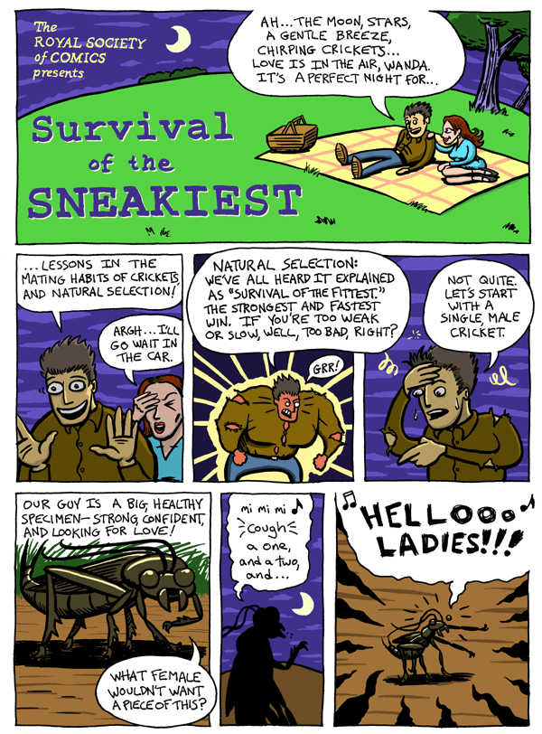
Name_______________________________

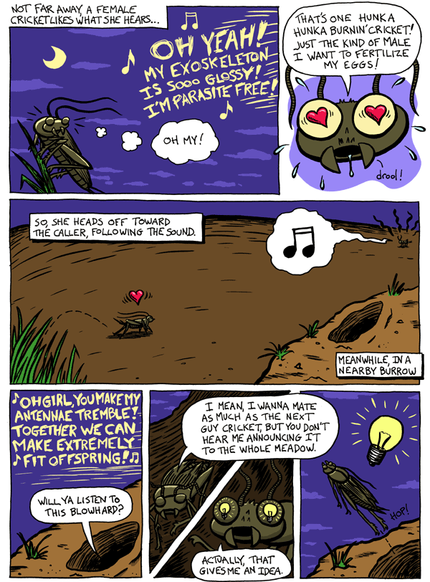

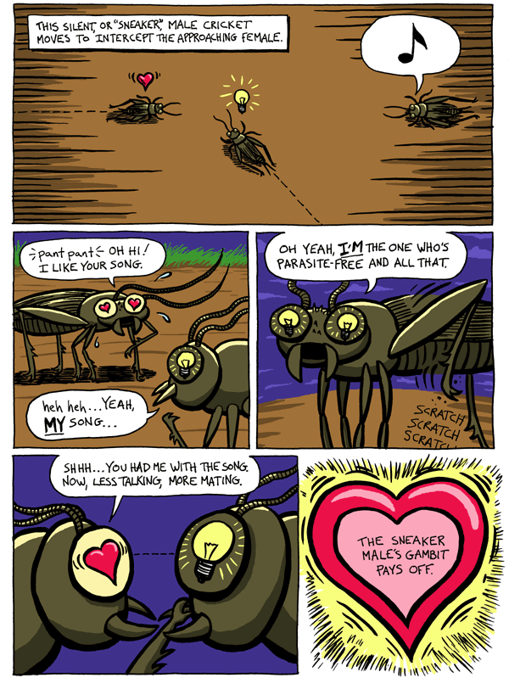

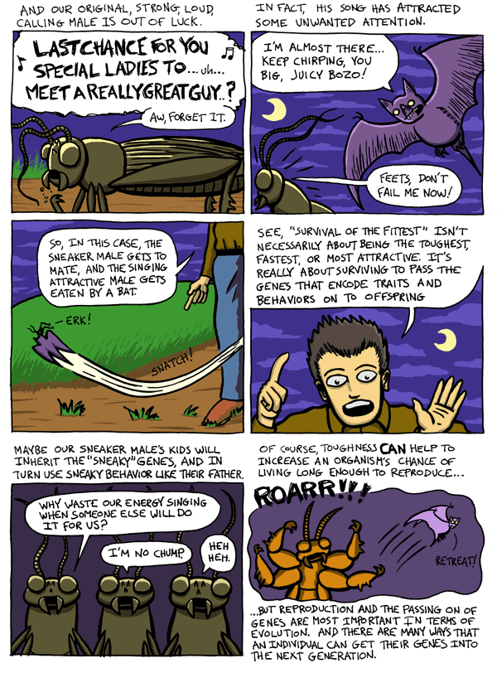
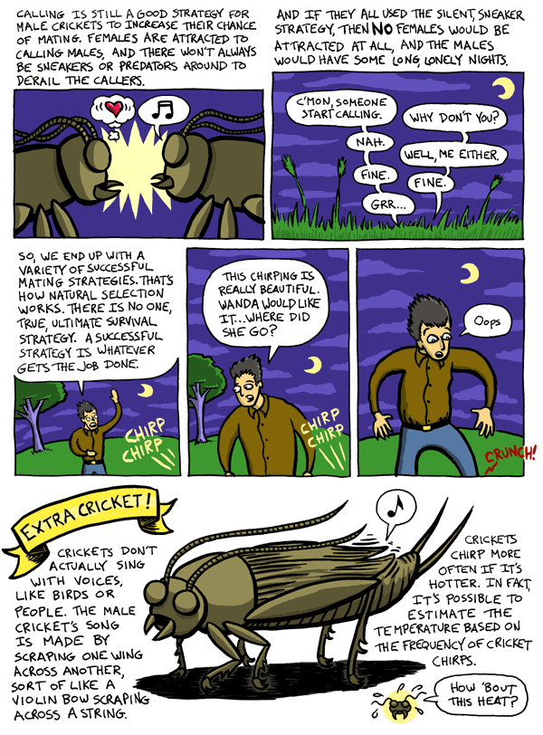

Discussion questions
- When it comes to crickets, what does fitness mean?

- Is calling good or bad for a cricket's fitness?

- Give some examples of selection at work in this cricket story.

- How does selection favor calling? How does selection favor not calling?

