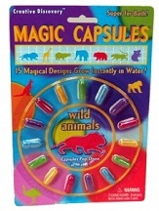
Sponge Capsules
Materials:
Sponge animals (purchased)
water (warm and room temperature)
beakers
stirrers (plastic spoons work)
salt
Purpose
- develop a hypothesis
- test a hypothesis
- collect data
- analyze data
- compose a lab report
Background: In the lab you will be given two gelatin capsules (per group) that contain sponge animals which are common toys usually labeled as "magic capsules". The animals will grow when placed in water. Consider the following questions about sponge animals.
Does the temperature of the water affect the rate of growth?
Does stirring the water affect the rate of growth?
Does the type of water, salt or tap, affect the rate of growth?
The Experiment
- As a group, choose one question and develop a hypothesis. Remember to state your hypothesis in a complete sentence and make sure that it is testable.
- Describe how you will test this hypothesis.
- Gather the needed materials and test your hypothesis.
- Construct a data table that shows your experiment and the data gathered. Make sure that the table is labeled correctly and is neat.
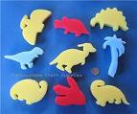
- Write your conclusions. Your conclusions should answer the experimental question. Use your data to support your answer. Suggest a reason why the sponge animals behaved the way they did.
- Share your results with the class.
- Turn in your completed flow-chart.

