Speciation and Population Genetics PowerPoint
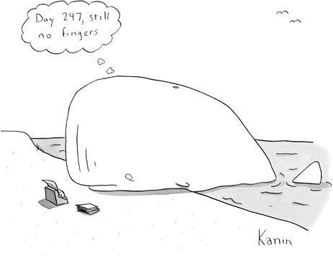
- A _________________________ is interbreeding populations of organisms that can produce healthy, fertile offspring. Two examples of a species are _____________ and _____________

2. _______________________________ is the evolution of one or more species from a single ancestor species.

Two examples of speciation are:

- Finches with their different shaped _____________

- Lizards with their different ____________________

3. There are TWO types of SPECIATION:
1. ________________________________
2. ________________________________

4. In allopatric speciation, a ____________________________ divides one population into two or more populations. The separate populations eventually will no longer be able to ________________ successfully with one another.

5. What are the PowerPoint examples for allopatric speciation: ____________________________________________________________

6. In sympatric speciation, a species evolves into a new __________________ without a physical barrier. The ancestor species and the new species live side by side during the _____________________________________.

7. Since speciation can take a long time, we may need to look at patterns of evolution that indicate how speciation has occurred. One example is:
Adaptive radiation (also called divergent evolution) when:

- _____________________________________________________________________________________________________________________________________________________________________

An example of this is a brown bear and a polar bear, they are related, however are adapted for different environments and conditions.

- Another example of adaptive radiation is ___________________________ where many species adapted to different niches on the Galapagos Islands.

- Convergent Evolution is another pattern of evolution that can give us information about how speciation can occur. In Convergent evolution: _____________________________________________________________________________________________________________________________________________________________________

An example of this is a maned wolf and a serval cat, they both have large ears to hear prey and very long legs even though they are not related

- Coevolution is another evolutionary pattern that can occur. It is when: _____________________________________________________________________________________________________________________________________________________________________

An example of this is the Madagascar orchid and the sphinx moth, draw their relationship below.

Evolution results from disruptions in genetic equilibrium. To understand this concept, we need to know:

- ____________________________ = Combined genetic
material of all the members of a given population.

- (All __________________________ of ___________________
involve changes in the gene pool).

14. In any gene pool, the number of each allele is a fraction of all the genes for a particular trait is known as ________________________________.

15. (Remember that genes often have two or more different forms, called ____________________
16. The hardy Weinberg principal states that: under certain conditions ________________________________________________________________________________________________________________________
17. (Conditions of the Hardy Weinberg Principal
On the left side of the table, write what the condition in, on the right side, draw a picture illustrating that condition. :

18. _________________is Random change in allele frequencies in a population due to chance events. 3 examples of events that can cause Genetic Drift:
1. _______________ 2. _________________ 3. ______________

In Summary:

19. Similar traits can develop in unrelated species occupying comparable _________

20. Power Point Example:

21. Interactions with other organisms affect _____________________________.

22. Power Point Example:

23. Many ______________ species can evolve from one ____________ species.

24. Evolution results from disruptions in _______________________________.

25. The normal distribution of variations in a population can be changed by ________

