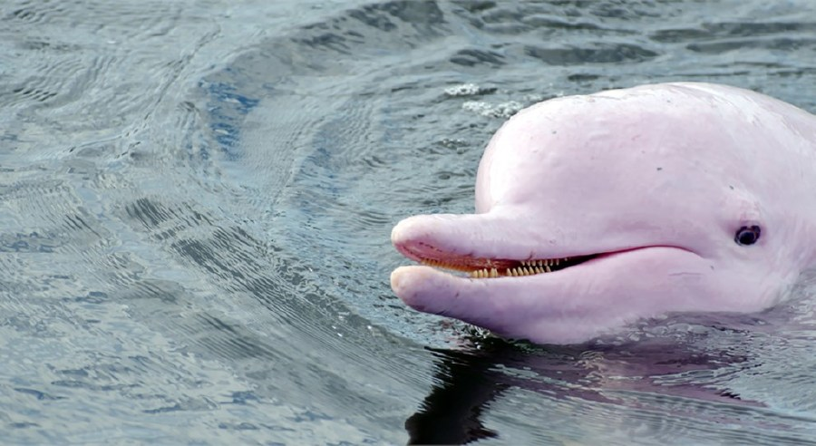
How Did Rare Pink Dolphin Get Its Color?
Pinky the bottlenose dolphin recently surfaced again in Louisiana, making a splash on social media.

By Rachel A. Becker, National Geographic
PUBLISHED SEPTEMBER 09, 2015

Pinky has surfaced again: The Louisiana bottlenose dolphin with a bubblegum-pink hue is making waves on social media this week. First spotted in 2007 in the Calcasieu River (Gulf Coast) by charter boat captain Erik Rue, Pinky is likely an albino, says Greg Barsh, a scientist who studies the genetics of color variation at the HudsonAlpha Institute for Biotechnology in Alabama.

Two telltale signs of albinism are Pinky's reddish eyes and blood vessels, which show through its pale skin that's devoid of pigment. Albinism occurs when cells that normally make the pigment melanin, responsible for skin, hair, and eye color, fail to produce it at normal levels, or at all.

This is usually because of a mutation in one of several genes. Pinky’s parents might have looked like typical dolphins, but both of them must have carried a single copy of the mutation in the same gene. Combined, those mutations resulted in the marine mammal's distinctive color.

Pinky has been around for about eight years, but albinism can come with several different health problems. The pigment melanin provides protection against the sun’s rays, and also plays an important role in eyesight: Without it, many albinos suffer from vision problems. Because of this, Barsh says, it’s rare to see an albino animal in the wild. Many more are found in laboratories or as pets, which don’t need to see to survive.

Boat caption Rue told local news station WGNO-TV that he recently witnessed Pinky mating, leading to speculation that it's a female and could be pregnant—though the animal's sex remains unconfirmed.
Whether Pinky’s own progeny, imminent or not, will also be pink remains to be seen—though it's unlikely.

That's because Pinky would have to mate with another albino for their babies to all be pink. If Pinky mated with a carrier of the mutated gene, like Pinky’s parents, their offspring would have a fifty-fifty chance of inheriting Pinky’s color. Since we don’t know yet how frequent those carriers are in the wild, Barsh says, we’ll have to wait and see if there's a pink surprise awaiting us.

