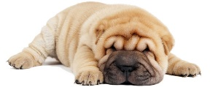
Mutation Exploration Name_________________________
GO TO: http://learn.genetics.utah.edu/content/variation/outcomes/
Shar Pei dogs:
- What type of protein is mutated in Shar Pei dogs? ____________________
- What is different about the HAS2 gene in Shar Peis? _________________________________________________________________
- What types of problems can this mutation cause in Shar Peis? _________________________________________________________________
Double-muscled cattle:
- Which protein is mutated in Double-muscled cattle? ______________________
- What type of mutation occurs in these cattle? _______________________
- How does this mutation affect the muscle cells? _________________________________________________________________
- What traits can variation in the myostatin gene cause in humans? _________________________________________________________________
Extra-toed cats:
- Which protein is affected in this mutation? ____________________________________
- What type of protein is it? _____________________________
- How does the single-base change in the DNA cause the extra toes? _________________________________________________________________
- Is this mutation dangerous for the cats or advantageous? _______________________________
Curly hair:
- Which type of protein is affected? ___________________________
- How many amino acids are affected in this mutation? ______________
- What are some other traits that other animals have that are made of keratin? _________________________________________________________________
- Is the curly hair mutation considered a disease or variation? _____________________________
Mendel’s Wrinkled Peas:
- What is the job of the SBE1 protein? ______________________________________________
- Explain how this insertion mutation cause wrinkling in the peas? ________________________________________________________________________________________________________________________________________
- If this mutation occurred in the similar gene for humans, what would the result be? ____________________________________________________________________
- In peas, is this mutation considered a disease or just variation? ___________________________
Disease resistance/Cystic Fibrosis:
- The same gene that causes life-threatening Cystic Fibrosis also makes people immune to: _________________________________________________________________
- What is one of the jobs of the CFTR protein involved? _________________________________________________________________
- What happens in the lungs of people with Cystic Fibrosis? _________________________________________________________________
- What types of organisms have the CFTR gene? _________________________________________________________________
- Why is this mutation considered both variation and disease? ________________________________________________________________________________________________________________________________________
Red Hair:
- What percent of people around the world have red hair? _________________
- In redheads, is the MC1R protein active or inactive? ______________________
- What are three examples of other organisms with MC1R variation? _________________________________________________________________
- In humans, why is this mutation considered both variation and possible disease? _________________________________________________________________
Song Learning in Birds:
- What is the purpose of singing in male zebra finches? __________________________________
- What is the job of the FOXP2 protein? ____________________________________________
- What happens to Zebra Finches with reduced levels of FOXP2? ___________________________
- What happens in people with a rare FOXP2 mutation? _________________________________________________________________
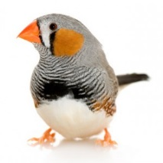
- Is a mutation in the FOXP2 gene considered variation, disease or both? ______________________

