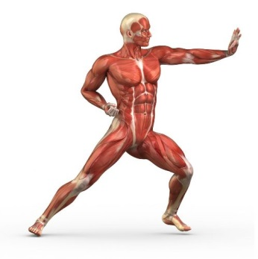
Name _______________________________ Period ___
Pairs of Skeletal Muscles Activity
(Use p. 948 for reference)

Muscles work in pairs to move bones and provide the skeletal system with motion. You can locate some of the pairs of muscles in your arms and legs.
Directions: Sit in a chair and follow the directions below:
- Put one hand under the chair and lift up. With your other hand, feel the muscles lifting up in the front and back of the arm.
  - Describe how the two muscles feel. Which one is harder, the one in the front or the one in the back?

  - Which muscle pulls the arm up (front or back)?

- Put your hand on top of the chair and push down. Use your other hand to feel the muscles again.
  - Which muscle, front or back, feels harder?

  - Which muscle is used to straighten your arm (front or back)?

- With the help of a friend, test the muscles in your upper leg. Have the friend hold your foot while you try to lift your leg. With one hand under your thigh and the other hand on top of the same thigh, compare the muscles.
  - Which muscle, underside of thigh or top of thigh, is the hardest during extension of the leg?

A muscle that bends bones at the joint is called a flexor.
A muscle that straightens bones at a joint is called an extensor.
- Looking back at the experiments with the arm, which muscle, front or back, is the flexor and which is the extensor?
  - Flexor - ___________________

  - Extensor - __________________

