Wednesday August 7, 2019
Living Earth: Week 1 Day 1

Standard: Become familiar with classmates and class norms including working with partners and families.
Learning Target: Apply collaborative group and partner techniques to practice class expectations and share information about yourself while learning about others.

Essential Question: How can we work together to benefit everyone in this class and maximize learning?

Agenda:
  - Note cards
  - “Mingle Bingo”

Thursday August 8, 2019
Living Earth: Week 1 Day 2

Standard: Become familiar with classmates and class norms including working with partners and families.
Learning Target: Apply collaborative group and partner techniques to practice class expectations and share information about yourself while learning about others.

Essential Question: How can we work together to benefit everyone in this class and maximize learning?

Agenda:
- “All about you” page (finish and turn in)

Friday August 9, 2019
Living Earth: Week 1 Day 3

Standard: Become familiar with classmates and class norms including working with partners and families.
Learning Target: Read a scientific article and identify the author’s claim, the evidence and the reasoning that supports the claim. Discuss.

Essential Question: What is the difference between claims, evidence and reasoning?

Agenda:
- Syllabus (Discuss)
- Discuss Claims, Evidence and Reasoning and write the definitions on the article.
- Read “Turtle Shell” Article
- “Claims, Evidence and Reasoning” (Turtle Shell) – Explain the claim of the article, the evidence noted in the article and the reasoning.

Monday August 12, 2019
Living Earth: Week 2 Day 4

Standard: Become familiar with classmates and class norms including working with partners and families.
Learning Target: Read a scientific article and identify the author’s claim, the evidence and the reasoning that supports the claim. Discuss.

Essential Question: What is the difference between claims, evidence and reasoning?

Agenda:
- Discuss Claims, Evidence and Reasoning and write the definitions on the article.
- “Claims, Evidence and Reasoning” (Turtle Shell) – Explain the claim of the article, the evidence noted in the article and the reasoning.
3. Media Center for Chromebooks

Tuesday August 13, 2019
Living Earth: Week 2 Day 5

Standard: Become familiar with classmates and class norms including working with partners and families.
Learning Target: Develop a hypothesis and design an experiment to catch the criminal who stole the puma skull. Collaboratively write a police report.

Essential Question: What is the difference between claims, evidence and reasoning?

Agenda:
- Design an experiment
- Run Experiment
- Complete “Police Report”
- Clean Up
- Share out

Wednesday August 14, 2019
Living Earth: Week 2 Day 6
Ms. Ballard’s (School Info)
Standard: Become familiar with classmates and class norms including working with partners and families.
Learning Target: Organize notebooks in order to prepare yourself for success in the class. Listen to

Essential Question: What is the difference between claims, evidence and reasoning?

Agenda:
- Ms. Ballard (Spoke to classes about school expectations).
- Note book set-up

Thursday August 15, 2019
Living Earth: Week 2 Day 7

Standard: Become familiar with classmates and class norms including working with partners and families.
Learning Target: Compare and contrast a living organism with a non-living object. Write Cornell notes about the characteristics that all living things share.

Essential Question: What are the characteristics that all living things share?

Agenda:
1. Compare and contrast (rock or shell vs. worm or beetle)
2. Write Cornell notes (8 characteristics)

Friday August 16, 2019
Living Earth: Week 2 Day 8

Standard: Characteristics of Life.
Learning Target: Write Cornell notes about the characteristics that all living things share. Add questions to the notes and summarize.

Essential Question: What are the characteristics that all living things share?

Agenda:
1. Finish Notes (p. 3)
2. Amoeba Sisters (Characteristics of Living Things)
4. Summarize notes
5. Review Activity (Quiz on Tues)

Monday August 19, 2019
Living Earth: Week 3 Day 9
(RALLY)
Standard: Characteristics of Life.
Learning Target: Add questions to the notes using Costa’s levels. Review the characteristics of life in a collaborative game and make predictions about why the population of buffalo in the Serengeti increased.

Essential Question: What are the characteristics that all living things share?

Agenda:
1. Add 2 questions (share out)
2. Practice/Review for quiz
3. Serengeti Discussion (p. 4)

Tuesday August 20, 2019
Living Earth: Week 3 Day 10
Standard: Characteristics of Life.
Learning Target: Write a claim answering which of two items is a living organisms and list evidence with reasoning to support your claim. Model possible predictions about why the population of buffalo in the Serengeti increased.

Essential Question: Why did the buffalo population increase?

Agenda:
1. Characteristics of Life Quiz
2. Serengeti Discussion (p. 4)
3. Serengeti Video Clip

Wednesday August 21, 2019
Living Earth: Week 3 Day 11
Standard: Characteristics of Life.
Learning Target: Determine needed areas of study to answer the question about why the buffalo population in the Serengeti increased.

Essential Question: What are the characteristics that all living things share?

Agenda:
1. Finished Buffalo (Serengeti) paper (p. 4)
2. Abiotic vs. Biotic factors (p. 5)
3. Serengeti Video Clip

Thursday August 22, 2019
Living Earth: Week 3 Day 12
Standard: Ecology.
Learning Target: Write statements about how abiotic and biotic factors can limit a population. Collaboratively research, design and create a model of a food web representing a specific biome.

Essential Question:
Agenda:
1. Add statement to Abiotic vs. Biotic factors (p. 5)
2. Limiting Factors and Carrying Capacity Video clips (discussion)
3. Food web projects

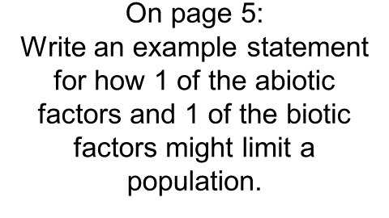

Friday August 23, 2019
Living Earth: Week 3 Day 13
Standard: Ecology.
Learning Target: Collaboratively research, design and create a model of a food web representing a specific biome.

Essential Question:
Agenda:
1. Food web projects

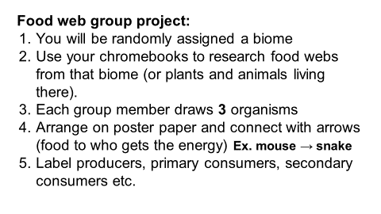

Monday August 26, 2019
Living Earth: Week 4 Day 14
Standard: Ecology.
Learning Target: Watch a video and answer key questions related to biodiversity. Collaboratively research, design and create a model of a food web representing a specific biome.

Essential Question:
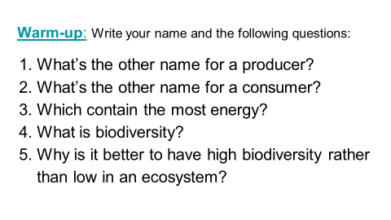
Agenda:
1. Biodiversity warm-up:
2. Food web projects:

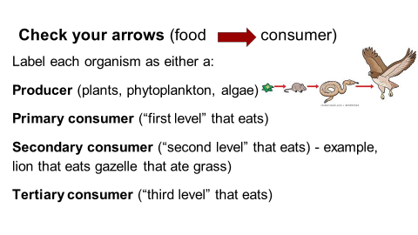

Tuesday August 27, 2019
Living Earth: Week 4 Day 15
Standard: Ecology
Learning Target: Collaboratively research, design and create a model of a food web representing a specific biome.

Essential Question: Why is biodiversity important?
Agenda:
1. Finish food web projects

Wednesday August 28, 2019
Living Earth: Week 4 Day 16
Standard: Ecology.
Learning Target: Read a scientific article and underline or highlight important ideas. Answer analysis questions to check for understanding.

Essential Question: What is biodiversity and why is it important?
Agenda:
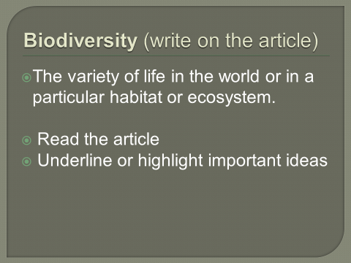
1. Vulture Article (p. 6):

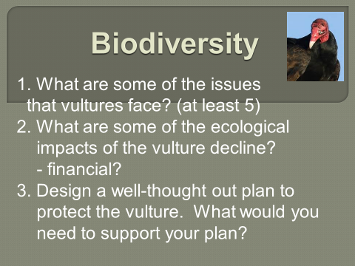

Thursday August 29, 2019
Living Earth: Week 4 Day 17
Standard: Ecology.
Learning Target: Create a detailed plan to protect the vultures and share out to the class.

Essential Question: What is biodiversity and why is it important?
Agenda:
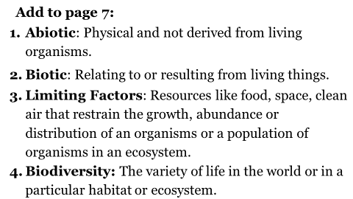
1.

2. Vulture Article Plans – share out (p. 6):

3. Ted Talk (California Condors)

Friday August 30, 2019
Living Earth: Week 4 Day 18
Standard: Ecology.
Learning Target: Write key vocabulary to study for a quiz, brainstorm impacts of humans on the environment and research invasive species.

Essential Question: How do humans impact the environment?
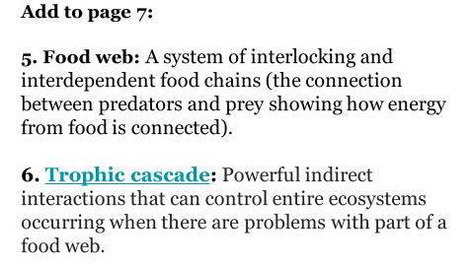
Agenda:
1. Write vocab 5 and 6:

2. Human impacts activity
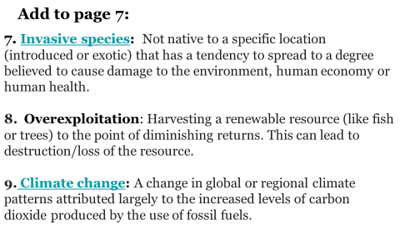
3. Write vocab 7-9:

Tuesday September 3, 2019
Living Earth: Week 5 Day 19
Standard: Ecology.
Learning Target: Watch video clips related to ecology vocab and research an invasive species. Collaboratively create a slideshow to share with classmates.

Essential Question: What is an invasive species and how can they affect the environment?
Agenda:
1. Video clips:

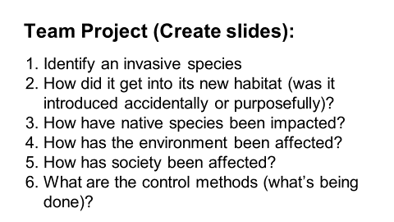
2. Start Invasive Species Projects:

Wednesday September 4, 2019
Living Earth: Week 5 Day 20
Standard: Ecology.
Learning Target: Collaboratively create a slideshow to teach classmates about an invasive species.

Essential Question: What is an invasive species and how can they affect the environment?
Agenda:

1. Invasive Species Projects:

Thursday September 5, 2019
Living Earth: Week 5 Day 21
Standard: Ecology
Learning Target: Collaboratively create a slideshow to teach classmates about an invasive species. Present to the class to teach them about an invasive species and their effects on the environment.

Essential Question: What is an invasive species and how can they affect the environment?
Agenda:
1. Invasive Species Projects:

2. Presentations

Friday September 6, 2019
Living Earth: Week 5 Day 22
Standard: Ecology
Learning Target: Present to the class to teach them about an invasive species and their effects on the environment. Write vocabulary to study for the test.

Essential Question: What is an invasive species and how can they affect the environment?
Agenda:
1. Presentations
2. Vocabulary

Monday September 9, 2019
Living Earth: Week 6 Day 23
Standard: Ecology
Learning Target: Write and discuss ecology specific vocabulary and watch video clips to solidify concepts. Collaboratively review by matching words to definitions.

Essential Question: What types of relationships can species have with each other in shared habitats?
Agenda:
1. Finish ecology vocab (p. 7) + video clips
2. “Matching review”

Tuesday September 10, 2019
Living Earth: Week 6 Day 24
Standard: Ecology
Learning Target: Watch a video clip of an example of a mutualistic relationship. Categorize symbiotic relationships by collaboratively matching cards with organisms and information. Explain two examples for each relationship and summarize.

Essential Question: What types of relationships can species have with each other in shared habitats?
Agenda:
1. Acacia tree and acacia ant video clip
2. “Symbiosis matching activity”
3. Page 8: explain 2 of each and summarize

Wednesday September 11, 2019
Living Earth: Week 6 Day 25
Standard: Ecology
Learning Target: Collaboratively review for quiz. Demonstrate knowledge of ecological concepts by scoring well on a quiz. .

Essential Question: What types of relationships can species have with each other in shared habitats?
Agenda:
1. Vocab matching review
2. Vocab quiz
3. Symbiosis video clips: cowbird, jewel wasp etc.
4. Update notebooks

Thursday September 12, 2019
Living Earth: Week 6 Day 26
Standard: Earth History
Learning Target: Brainstorm ideas to explain the phenomena that early insects were larger than insects today. Review what’s known about earth’s history.

Essential Question: Why were prehistoric insects larger than insects today?
Agenda:
1. “Insect size phenomenon” – whiteboards
2. History of earth background info (video clip)
3. Intro timeline project

Friday September 13, 2019
Living Earth: Week 6 Day 27
Standard: Earth History
Learning Target: Model earth’s history by constructing a timeline with key atmospheric, geological and biological events.

Essential Question: How was early earth different from earth today?
Agenda:
1. Earth History Timelines

Monday September 16, 2019
Living Earth: Week 7 Day 28

Standard: Earth History
Learning Target: Model earth’s history by constructing a timeline with key atmospheric, geological and biological events.

Essential Question: How was early earth different from earth today?
Agenda:
1. Earth History Timelines

Tuesday September 17, 2019
Living Earth: Week 7 Day 29

Standard: Earth History
Learning Target: Model earth’s history by constructing a timeline with key atmospheric, geological and biological events. Research a time period to make a poster to present to the class.

Essential Question: How was early earth different from earth today?
Agenda:
1. Earth History Timelines
2. Start Partner Earth History Period posters

Wednesday September 17, 2019
Living Earth: Week 7 Day 30

Standard: Earth History
Learning Target: Model earth’s history by constructing a timeline with key atmospheric, geological and biological events. Research a time period to make a poster to present to the class.

Essential Question: How was early earth different from earth today?
Agenda:
1. Earth History Timelines – finish
2. Earth History Period posters

Thursday September 18, 2019
Living Earth: Week 7 Day 31

Standard: Earth History
Learning Target: Research a time period to make a poster to present to the class. Brainstorm prediction for future earth and summarize a video on the sixth mass extinction.

Essential Question: How was early earth different from earth today?
Agenda:
1. Earth History Period posters
2. Brainstorm: predictions for earth (p. 9)
3. Extinction video (plus summary) page 9

Friday September 19, 2019
Living Earth: Week 7 Day 32

Standard: Cell Energy (Photosynthesis and Cellular Respiration)
Learning Target: Watch a video clip and summarize information about the 6th mass extinction, Discuss upcoming biome projects and write Cornell notes.

Essential Question: How do we have oxygen in our atmosphere?
Agenda:
1. Pers. 2 and 6: Watch video and summarize, Periods 4 and 5: discuss summaries.
2. “Biome in a Bottle” discussion
3. Photosynthesis notes (p. 10)

Monday September 23, 2019
Living Earth: Week 8 Day 33

Standard: Cell Energy (Photosynthesis and Cellular Respiration)
Learning Target: Compete in an exercise to review photosynthesis, write Cornell notes about photosynthesis and summarize.

Essential Question: How do we have oxygen in our atmosphere?
Agenda:
1. Photosynthesis competition.
2. Photosynthesis notes (p. 10)
3. Summary

Tuesday September 24, 2019
Living Earth: Week 8 Day 34

Standard: Cell Energy (Photosynthesis and Cellular Respiration)
Learning Target: Collaboratively plan and research for the biome in a bottle project. Complete a proposal to document which group member is responsible for which portion.

Essential Question: How will you set up your biome in a bottle?
Agenda:
1. Biome Planning

Period 2 had HERO TRAINING

Wednesday September 25, 2019
Living Earth: Week 8 Day 35
SUB DAY
Standard: Cell Energy (Photosynthesis and Cellular Respiration)
Learning Target: LIFE: Plants video

Essential Question:
Agenda:
1. Life “Plants” with video guide

Thursday September 26, 2019
Living Earth: Week 8 Day 36
SUB DAY
Standard: Cell Energy (Photosynthesis and Cellular Respiration)
Learning Target: COSMOS: “Lost Worlds”

Essential Question:
Agenda:
1. Cosmos: “Lost Worlds” episode with video guide

Friday September 27, 2019
Living Earth: Week 8 Day 37
Standard: Cell Energy (Photosynthesis and Cellular Respiration)
Learning Target: HERO TRAINING

Essential Question:
Agenda:
1. Periods 2 and 6 researched biome planning
2. Periods 4 and 5 had HERO training.

Monday September 30, 2019
Living Earth: Week 9 Day 38
Standard: Cell Energy (Photosynthesis and Cellular Respiration)
Learning Target: Summarize Cornell notes and read and analyze a scientific article about glucose.

Essential Question: How and why does glucose turn into cellulose and starch?
Agenda:
1. Finish notes (p. 10)
2. Summarize
3. Glucose Article
4. Article analysis

Tuesday October 1, 2019
Living Earth: Week 9 Day 39
Standard: Cell Energy (Photosynthesis and Cellular Respiration)
Learning Target: Model photosynthesis using Froot Loops, answer analysis questions and summarize.

Essential Question: How do plants use photosynthesis to create a source of macromolecules for themselves and other organisms?

Agenda:
1. Photosynthesis Model
2. Analysis Questions
3. Summary

Wednesday October 2, 2019
Living Earth: Week 9 Day 40
Standard: Cell Energy (Photosynthesis and Cellular Respiration)
Learning Target: Model photosynthesis using Froot Loops, answer analysis questions and summarize.

Essential Question: How do plants use photosynthesis to create a source of macromolecules for themselves and other organisms?

Agenda:
1. Finish analysis and summary
2. Notebook “pre-check”

Thursday October 3, 2019
Living Earth: Week 9 Day 41
Standard: Cell Energy (Photosynthesis and Cellular Respiration)
Learning Target: Cut out and organize reactants and products to represent photosynthesis and collaboratively plan a model.

Essential Question: What are the reactants and products of photosynthesis?

Agenda:
1. Photosynthesis “Cut-outs” (p. 13)
2. Biome project (check-in)
3. Macromolecule Reading

Friday October 4, 2019
Living Earth: Week 9 Day 42
Standard: Cell Energy (Photosynthesis and Cellular Respiration)
Learning Target: Read a scientific article and mark for specific information. Use the information to classify information into a grid to compare and contrast the different macromolecules.

Essential Question: What are similarities and differences between the 4 groups of macromolecules?

Agenda:
1. Macromolecule reading
2. “Macromolecule Study Guide” p. 14
3. Summary:
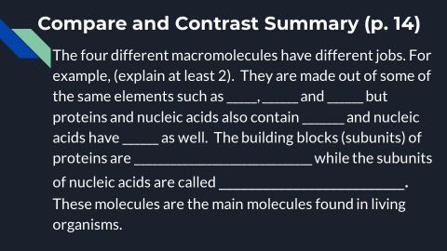

Tuesday October 8, 2019
Living Earth: Week 10 Day 43
Standard: Cell Energy (Photosynthesis and Cellular Respiration)
Learning Target: Build models to demonstrate the connection between photosynthesis and cellular respiration.

Essential Question: How are photosynthesis and cellular respiration connected?

Agenda:
1. Biome Building
2. “Macromolecule Study Guide” p. 14
3. Summary:

Wednesday October 9, 2019
Living Earth: Week 10 Day 44
Standard: Cell Energy (Photosynthesis and Cellular Respiration)
Learning Target: Build models to demonstrate the connection between photosynthesis and cellular respiration.

Essential Question: How are photosynthesis and cellular respiration connected?

Agenda:
1. Biome Building
2. “Macromolecule Study Guide” p. 14
3. Summary:

4. Join Google Classroom and begin Lab reports

Thursday October 10, 2019
Living Earth: Week 10 Day 45
Standard: Cell Energy (Photosynthesis and Cellular Respiration)
Learning Target: Answer questions to prepare for quiz, watch a video clip to review and write Cornell notes about Cellular Respiration.

Essential Question: How are photosynthesis and cellular respiration connected?

Agenda:
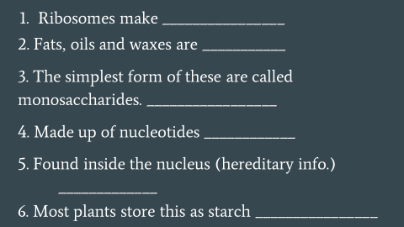
1. Macromolecule Warmup:

2. Amoeba Sisters
3. Share-out summary (p. 14)
4. Cell Respiration notes (p. 15)

Friday October 11, 2019
Living Earth: Week 10 Day 46
Standard: Cell Energy (Photosynthesis and Cellular Respiration)
Learning Target: Answer questions to prepare for quiz, and write Cornell notes about Cellular Respiration.

Essential Question: How are photosynthesis and cellular respiration connected?

Agenda:
1. Macromolecule Warmup #2:
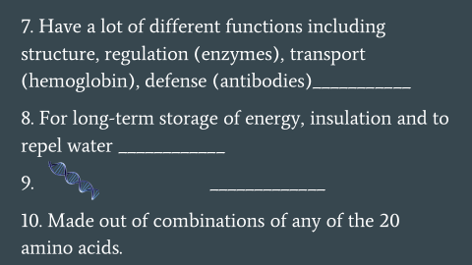

2. Cell Respiration notes (p. 15)

Monday October 14, 2019
Living Earth: Week 11 Day 47
Standard: Cell Energy (Photosynthesis and Cellular Respiration)
Learning Target: Answer a question to prepare for quiz, and write Cornell notes about Cellular Respiration. Summarize your notes and write two questions.

Essential Question: How are photosynthesis and cellular respiration connected?

Agenda:
1. Macromolecule Test Practice #3: Which macromolecule can be made by adipose cells?
2. Cell Respiration notes (p. 15)
3. Summary
4. Two questions (add to p. 15)

Tuesday October 15, 2019
Living Earth: Week 11 Day 48
Standard: Cell Energy (Photosynthesis and Cellular Respiration)
Learning Target: Demonstrate knowledge of macromolecules by scoring well on a quiz. Write a lab report about your biome projects.

Essential Question: How are photosynthesis and cellular respiration connected?

Agenda:
1. Macromolecule Test
2. Lab report (biomes)

Wednesday October 16, 2019
Living Earth: Week 11 Day 49
College Prep Day

Thursday October 17, 2019
Living Earth: Week 11 Day 50

Standard: Cell Energy (Photosynthesis and Cellular Respiration)
Learning Target: Write a paragraph that explains the connection between photosynthesis and cellular respiration to practice for the exam. Revise slides 18 of the lab reports.

Essential Question: How are photosynthesis and cellular respiration connected?

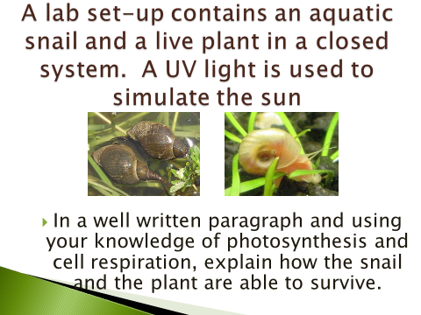
Agenda:
1. Practice Paragraph:

2. Finish cut-outs on page 16

Friday October 18, 2019
Living Earth: Week 11 Day 51

Standard: Cell Energy (Photosynthesis and Cellular Respiration)
Learning Target: Write a hypothesis about what will happen if yeast cells undergo cellular respiration. Write data and conclusions in a ‘mini-lab report.’ Revise slides 1-8 of the biome lab reports and review your group for slide 8.

Essential Question: How are photosynthesis and cellular respiration connected?

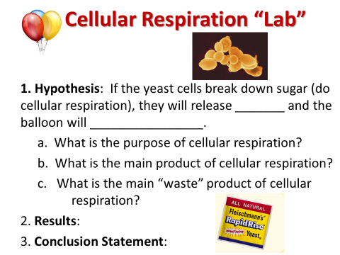
Agenda:
1. “Cell respiration Demo” – set up and write hypothesis:

2. Revise lab reports (add slide 8)
3. Write conclusions for lab report

Monday October 21, 2019
Living Earth: Week 12 Day 52

Standard: Cell Energy (Photosynthesis and Cellular Respiration)
Learning Target: Review photosynthesis and cellular respiration through reading text and answering questions, interpreting graphs and drawing a model.

Essential Question: How are photosynthesis and cellular respiration connected?

Agenda:
1. Read “Lesson 19”
2. Answer questions (p. 18)
3. Analyze graphs (p. 18)
4. Draw model

Tuesday October 22, 2019
Living Earth: Week 12 Day 53

Standard: Cell Energy (Photosynthesis and Cellular Respiration)
Learning Target: Review the connection between cellular respiration and photosynthesis by using the whiteboards and collaboratively modeling. Review cellular respiration through reading an article and answering questions.

Essential Question: How are photosynthesis and cellular respiration connected?

Agenda:
1. Whiteboard review
2. Cell Respiration (exercise) article (p. 19)

Wednesday October 23, 2019
Living Earth: Week 12 Day 54

Standard: Cell Energy (Photosynthesis and Cellular Respiration)
Learning Target: Demonstrate understanding of photosynthesis and cellular respiration by scoring well on an exam.

Essential Question: How are photosynthesis and cellular respiration connected?

Agenda:
1. Exam (model and questions)

Thursday October 24, 2019
Living Earth: Week 12 Day 55

Standard: Cell Energy (Photosynthesis and Cellular Respiration)
Learning Target: Listen to an NPR podcast about the Roadless rule and answer questions. Organize and complete notebooks.

Essential Question: What consequences would there be of lifting the Roadless Rule?

Agenda:
1. Podcast and questions
2. Organize notebooks (catch up)

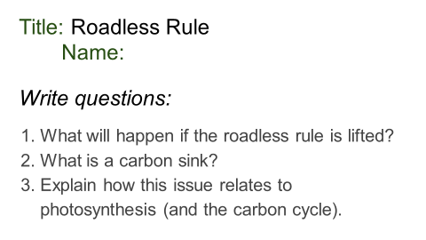

Friday October 25, 2019
Living Earth: Week 12 Day 56

Standard: DNA
Learning Target: Gather evidence to support a claim for the structure of DNA and build a model that represents your claim.

Essential Question: What is the structure of DNA?

Agenda:
1. DNA evidence
2. Build model (claim)
3. Explain reasoning (column 2)
4. Paragraph

Monday October 28, 2019
Living Earth: Week 13 Day 57

Standard: DNA
Learning Target: Gather evidence to support a claim for the structure of DNA and build a model that represents your claim.

Essential Question: What is the structure of DNA?

Agenda:
1. Finish models (claims)
2. Explain reasoning (column 2)
3. Paragraph (p. 20) (evidence – reasoning – claim)
4. “Twisting Tale of DNA”
5. “DNA replication”

Tuesday October 29, 2019
Living Earth: Week 13 Day 58

Standard: Mutations (DNA)
Learning Target: Write Cornell notes to distinguish between the different types of chromosomal and gene mutations.

Essential Question: What can happen if there are mistakes in the DNA?

Agenda:
1. Attach DNA model “claims” to p. 20
2. Mutation notes (p. 21)
3. Summary
4. Mutation video clip (Amoeba sisters)

Wednesday October 30, 2019
Living Earth: Week 13 Day 59

Standard: Mutations
Learning Target: Mark and highlight Cornell notes and share out summaries. Match mutation “stories” to definitions and discuss. Answer analysis questions.

Essential Question: What are the different types of mutations?

Agenda:
1. Mark notes (p. 21)
2. Summary share-out
3. “Mutation Stations” (p. 22)
4. Analysis questions

Thursday October 31, 2019
Living Earth: Week 13 Day 60

Standard: Mutations
Learning Target: Read scientific information online to complete a “Webquest” discussing various examples of mutations.

Essential Question: What are the different types of mutations? Are they harmful, beneficial or neither?

Agenda:
1. “Mutation Exploration” (p. 23)

Friday November 1, 2019
Living Earth: Week 13 Day 61

Standard: Mutations
Learning Target: Read a scientific article, annotate, evaluate and discuss. Watch a video clip about albinism and summarize and write a reflection about a second video clip.

Essential Question: What can go wrong with DNA? Are the effects harmful or beneficial?

Agenda:
- Brainstorm
- Read article
- Annotate
- Analyze
- Video 1 (summary)
- Video 2 (reflection)

Monday November 4, 2019
Living Earth: Week 14 Day 62

Standard: Mutations
Learning Target: Write a reflection about a second video clip following a boy with albinism. Watch a video clip on adaptations and brainstorm a possible adaptation. Categorize into structural or behavioral and write notes about natural selection.

Essential Question: What are adaptations?

Agenda:
- Video 2 (reflection) – p. 24
- Adaptations (sticky notes)
- Natural selection PPT (p. 25)

Tuesday November 5, 2019
Living Earth: Week 14 Day 63

Standard: Adaptations
Learning Target: Write predictions about plant adaptations. Write key facts about natural selection, watch video clips, sketch and summarize.

Essential Question: What are adaptations?

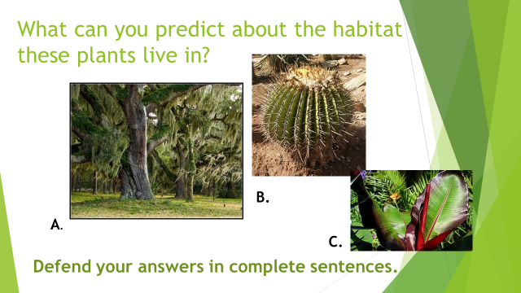
Agenda:
- Plant adaptation warm-up:
- Natural selection PPT (p. 25)
- Summary

Wednesday November 6, 2019
Living Earth: Week 14 Day 64

Standard: Adaptations
Learning Target: Write predictions about peacock adaptations. Write key facts about natural selection, watch video clips, sketch and summarize.

Essential Question: What are adaptations?

Agenda:
- Peacock adaptation warm-up (just discuss):
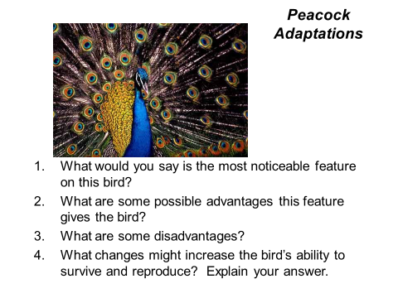
- Natural selection PPT (p. 25)

Thursday November 7, 2019
Living Earth: Week 14 Day 65

Standard: Adaptations/Evolution
Learning Target: Read, analyze and discuss a scientific article about the evolution of squid eyes.

Essential Question: How has the Sperm Whale influenced the evolution of Giant Squid eyes?

Agenda:
- Read article
- Mark/annotate (p. 26)
- Analysis questions (p. 26)

Friday November 8, 2019
Living Earth: Week 14 Day 66

Standard: Adaptations/Evolution
Learning Target: Explore the anatomy of the squid and focus on what adaptations it has that would help it survive in the ocean.

Essential Question: How are squid adapted to survive in the ocean?

Agenda:
1. Squid Exploration
2. Adaptation Chart

Tuesday November 12, 2019
Living Earth: Week 15 Day 67

Standard: Adaptations/Evolution
Learning Target: Consider how adaptations might affect the survival of species and draw examples of the principles of natural selection.

Essential Question: What adaptations might have allowed squid to survive for 500 million years?

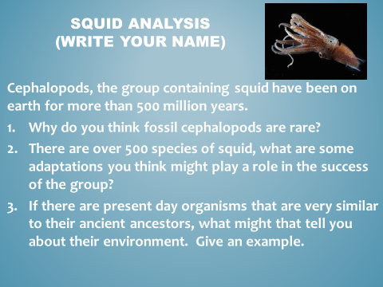
Agenda:
1. Cephalopod Warm-up:

2. Finish p. 25 (Natural Selection PPT)

Wednesday November 13, 2019
Living Earth: Week 15 Day 68

Standard: Adaptations/Evolution
Learning Target: Watch video clips and discuss the different types of fossils. Take key notes from a video about the evolution of eyes in different species.

Essential Question: How are organisms fossilized?

Agenda:
1. “How fossils are made”
2. Started Evolve “Eyes” (p. 27)

Thursday November 14, 2019
Living Earth: Week 15 Day 69

Standard: Adaptations/Evolution
Learning Target: Take key notes from a video about the evolution of eyes in different species.

Essential Question: How have eyes evolved over time?

Agenda:
1. Evolve “Eyes” (p. 27)

Friday November 15, 2019
Living Earth: Week 15 Day 70

Standard: Adaptations/Evolution
Learning Target: Brainstorm natural selection and then randomly determine characteristics of an environment to create an organism with adaptations that would help it survive in its situation.

Essential Question: How is your creature adapted to its environment?
Agenda:
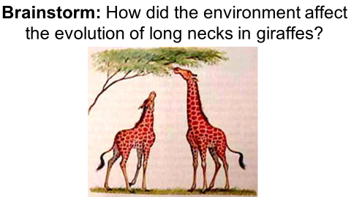
1.

2. “Design a creature”

Monday November 18, 2019
Living Earth: Week 16 Day 71

Standard: Adaptations/Evolution
Learning Target: Organize notebooks and watch a video clip about the evidence for evolution. Analyze amino acids to look for relatedness in species.

Essential Question: How do organisms evolve?

Agenda:
1. Finish and turn in “creatures”
2. Check organization of notebooks (add new “Table of Contents” page)
3. “Stated Clearly” evidence of evolution
4. Amino Acid comparisons (p. 29)

Tuesday November 19, 2019
Living Earth: Week 16 Day 72

Standard: Adaptations/Evolution
Learning Target: Watch a video clip on the speciation of finches in the Galapagos and discuss the evolution of the pepper moths. Understand how speciation occurs by writing key facts from a PowerPoint.

Essential Question: How do new species arise?

Agenda:
1. “Beak of the Finch” (HHMI) video clip
2. Speciation PPT (p. 30)

Wednesday November 20, 2019
Living Earth: Week 16 Day 73

Standard: Adaptations/Evolution
Learning Target: Watch a video clip about evolution and write about something that you learned. Understand how speciation occurs by writing key facts from a PowerPoint.

Essential Question: How do new species arise?

Agenda:
1. “12 days of evolution” video clip
2. Speciation PPT (p. 30)

Thursday November 21, 2019
Living Earth: Week 16 Day 74

Standard: Adaptations/Evolution
Learning Target: Watch a video clip about evolution and discuss the evolution of the pepper moths. Understand how speciation occurs by writing key facts from a PowerPoint.

Essential Question: How do new species arise?

Agenda:
1. “Science of skin color” (Ted Ed) video clip
2. Pepper Moth Practice
2. Speciation PPT (p. 30)

Friday November 22, 2019
Living Earth: Week 16 Day 75

Standard: Evolution
Learning Target: Watch a video and answer questions about the evolution of dogs.

Essential Question: What is evidence that dogs co-evolved with humans?

Agenda
1) “Dogs Decoded” (with guide)

Monday December 2, 2019
Living Earth: Week 17 Day 76

Standard: Evolution
Learning Target: Understand convergent evolution by matching organisms with analogous structures in similar niches. Write key facts from a PowerPoint on speciation.

Essential Question: How do organisms have analogous structures in similar environments?

Agenda
1) Convergent Evolution Chart (p. 31)
2) Speciation PowerPoint (p. 30)

Tuesday December 3, 2019
Living Earth: Week 17 Day 77

Standard: Evolution
Learning Target: Read and analyze an article about the evolution of lizards in a white sand environment. Discuss and interpret each paragraph with a partner and summarize.

Essential Question: How did the lizards adapt to their environment?

Agenda
1) Lizard article reading activity (p. 32)
2) Lizard summary (p. 32)
3) Speciation PowerPoint (p. 30)

Wednesday December 4, 2019
Living Earth: Week 17 Day 78

Standard: Students know variation within a species increases the likelihood that at least some members of a species will survive under changed environmental conditions.

Learning Target: Read and analyze a scientific article on the evolution of baleen in whales. Compare the evolutionary aspects of the whale article to the lizard article analyzed yesterday and write a comparison summary.

Essential Questions: How are genes related to evolution?
Agenda:
- Whale article
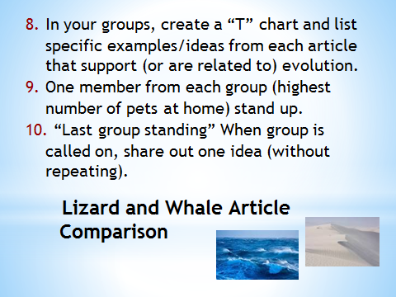
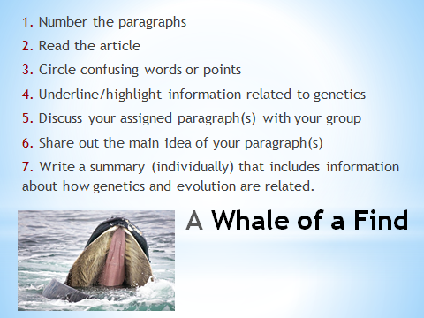
- Lizard and Whale article comparison

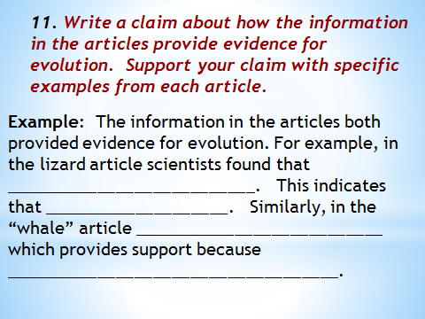

Thursday December 5, 2019
Living Earth: Week 17 Day 79

Standard: Students know variation within a species increases the likelihood that at least some members of a species will survive under changed environmental conditions.

Learning Target: Discuss claims comparing the evolutionary evidence in whales and lizards. Review patterns of evolution by answering questions and writing key facts from a PowerPoint.

Essential Questions: How are genes related to evolution?
Agenda:
- Share out claim paragraphs (p. 33)
- Finish PowerPoint (p. 30)
- Patterns of Evolution (p. 34)

Friday December 6, 2019
Living Earth: Week 17 Day 80

Standard: Students know variation within a species increases the likelihood that at least some members of a species will survive under changed environmental conditions.

Learning Target: Discuss claims comparing the evolutionary evidence in whales and lizards. Review patterns of evolution by answering questions and writing key facts from a PowerPoint.

Essential Questions: How are genes related to evolution?
Agenda:
- Honors (Prep Escape Boxes – decide teams)
- Moth Practice (#2)
- Start Human Evolution (cladograms) – p. 35

1. CP: Human Evolution (p. 35)

Monday December 9, 2019
Living Earth: Week 18 Day 81

Standard: Students know variation within a species increases the likelihood that at least some members of a species will survive under changed environmental conditions.

Learning Target: Watch video clips and write answers to questions about evolution. Practice interpreting cladograms.

Essential Questions: How have humans evolved?
Agenda:
- Honors (Escape Boxes – Media Center)
- CP: Human Evolution – p. 35

Tuesday December 10, 2019
Living Earth: Week 18 Day 82

Standard: Students know variation within a species increases the likelihood that at least some members of a species will survive under changed environmental conditions.

Learning Target: Watch video clips and write answers to questions about evolution. Practice interpreting cladograms.

Essential Questions: How have humans evolved?
Agenda:
- Honors (Escape Boxes – Media Center) – Day 2
- CP: Human Evolution – p. 35
- Moth Practice: Quiz tomorrow
- Skull lab intro (page 36)

Wednesday December 11, 2019
Living Earth: Week 18 Day 83

Standard: Students know variation within a species increases the likelihood that at least some members of a species will survive under changed environmental conditions.

Learning Target: Demonstrate understanding of natural selection by scoring well on a quiz.

Essential Questions: How did Pepper Moths evolve?
Agenda:
- Natural Selection (Pepper Moth) quiz
- Discuss, practice for “Mystery of the Skulls” lab

Thursday December 12, 2019
Living Earth: Week 18 Day 84

Standard: Students know variation within a species increases the likelihood that at least some members of a species will survive under changed environmental conditions.

Learning Target: Determine the relatedness of hominins.

Essential Questions: How did humans evolve?
Agenda:
- Skull Lab

Friday December 13, 2019
Living Earth: Week 18 Day 85

Standard: Students know variation within a species increases the likelihood that at least some members of a species will survive under changed environmental conditions.

Learning Target: Determine the relatedness of hominins.

Essential Questions: How did humans evolve?
Agenda:
- Skull Lab

Monday December 16, 2019
Living Earth: Week 19 Day 86

Standard: Students know variation within a species increases the likelihood that at least some members of a species will survive under changed environmental conditions.

Learning Target: Demonstrate understanding of evolution by scoring well on an exam.

Essential Questions: How well did you organize your notebook?
Agenda:
- Evolution Test (Notebook #5)

Tuesday December 17-Thurs. Dec. 19, 2019
Living Earth: Week 19 Day 87-89

Standard: Students know variation within a species increases the likelihood that at least some members of a species will survive under changed environmental conditions.

Learning Target: Demonstrate understanding of natural selection through creating a scenario artistically and in writing to model natural selection.

Essential Questions: What is evolution and how does it happen?
Agenda:
- Natural Selection Posters

Friday December 20, 2019
Living Earth: Week 19 Day 90

Standard: Students know variation within a species increases the likelihood that at least some members of a species will survive under changed environmental conditions.

Learning Target: Demonstrate understanding of natural selection through creating a scenario artistically and in writing to model natural selection.

Essential Questions: What is evolution and how does it happen?
Agenda:
- Natural Selection Poster Gallery Walk
- Class Reflection

