Name____________________________ Date _____
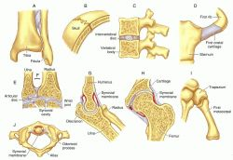
Joints of the Skeletal System (p. 944 in book)
A joint is a place at which two bones meet. There are two kinds of joints called movable and immovable. Immovable joints are found where bones have fused together such as in the skull. Moveable joints allow for some kind of movement between two bones. Bones do not bend, so movement can only occur at the joints.
There are different kinds of moveable joints. The most common are the ball-and-socket joint, the hinge joint, and the ellipsoid joint. The pivot joint in the neck is responsible for our ability to raise and lower our heads or turn our heads from side to side. The ellipsoid joint in your wrist allows you to wave your hand. The hinge joint of the elbows allows for forward and backward motion. The ball-and-socket joint of the shoulders allows for movement in many directions.
Directions: Compare the movement of the hinge and ball-and socket joints.
- Move your arm without moving the upper arm at the shoulder. Describe the kind of movement permitted by the hinge joint of your elbow.

- Now move your arm, concentrating on the variety of movements permitted by the ball-and-socket joint of the shoulder. Write down observations of the kinds of movements possible.

- How does the movement of the hinge joint of the elbow compare with the movement of the ball-and-socket joint of the shoulder?

- The knees and hips are similar to the arms and shoulders. Which represents the hinge joint and which represents the ball-and-socket joint?

- Why would a ball-and-socket joint at the knees create problems for walking?

