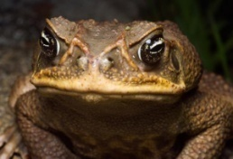
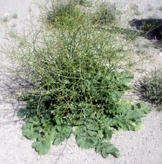
Invasive Species Internet Project
Species ______________________
Team members_________________________________
Human beings have often moved different species either intentionally or accidently from their original habitats to new locations sometimes in order to meet some human need. When this happens, the environment is altered, but not always in the manner originally intended. While some people support human manipulation of the habitats of various species, others argue that it may not be worth the potential risks.
Objectives:
Students will create a short slide presentation that:
- identifies a species that has been relocated by human intervention and the reasons for that intervention;
- identifies how the relocated species and other species have been affected by the relocation;
- identifies how the environment and human society have been affected by the relocation; and what control methods are and
- outlines arguments for and against the wisdom of such human manipulation of other species.

Invasive Species Internet Project
Species _______________________
Team members_________________________________
Human beings have often moved different species either intentionally or accidently from their original habitats to new locations sometimes in order to meet some human need. When this happens, the environment is altered, but not always in the manner originally intended. While some people support human manipulation of the habitats of various species, others argue that it may not be worth the potential risks.
Objectives:
Students will create a short slideshow that:
- identifies a species that has been relocated by human intervention and the reasons for that intervention;
- identifies how the relocated species and other species have been affected by the relocation;
- identifies how the environment and human society have been affected by the relocation; and what control methods are and
- outlines arguments for and against the wisdom of such human manipulation of other species.

