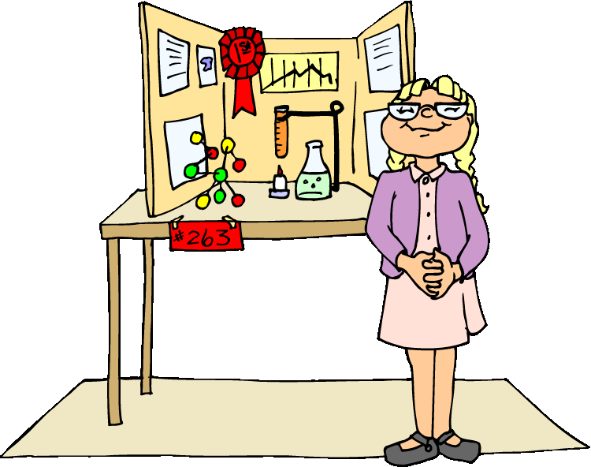
Honors Biology
“Science Fair*” Project

A science experiment is an investigation of a question about a science topic that interests you. The difference between this kind of project and other ways of working on a problem is the use of a systematic plan called the Scientific Method. *Once your Experiment is approved, you can start your experiment at any time but be sure to have the experimental design at least verbally approved first.
TIMELINE and EXPECTATIONS
- Experiment Proposal (Identify and state the problem (usually as a Question) and purpose of the investigation.  This is important, talk to me as soon as you have an idea – do  not plan to “re-do” an elementary or middle school project. | Due:  Friday, Jan. 15th
- Research/Introduction Find out what is known about your question from reading about and possibly talking with experts (Include at least 3 primary (books or scientific articles) sources (one of which can be an expert interview). | Due:  Wed., Jan. 27th
- Hypothesis: Write a statement expressing your opinion about the question. Make predictions about what will happen based on your background research. | Due:  Wed., Feb. 17th
- Experimental Design: Plan an experiment that will test your hypothesis. Your experiment should contrast a control group or situation with a test group or situation. Describe how you will do the experiment (your procedure or Method). List your materials and your protocols. | Due:  Wed., March 2nd
- Conduct the experiment and record all data, observations, measurements in appropriate data tables. | Due:  Wed., March 16th
- Analyze data and display the data as graphs, histograms or charts. | Due:  Wed., April 13th
- Conclusions: explain what happened in the experiment, whether your experiment supported or disproved the hypothesis (Your experiment does not have to prove it to be successful)! Did your experiment suggest any additional ideas for future research or experimentation? | Due:  Wed., May 4th
- Completed Lab Report (Introduction with sources cited, question, hypothesis, methods, results and conclusions) | Due:  Wed., May 25th
- Visual Presentation (tri-fold board or PowerPoint) | Due: Wed., June 1st
*The timing of this project does not allow you to enter your project into the “real” science fair but you may enter this project next year if you are interested.

