A New Chapter in the Immortal Life of Henrietta Lacks
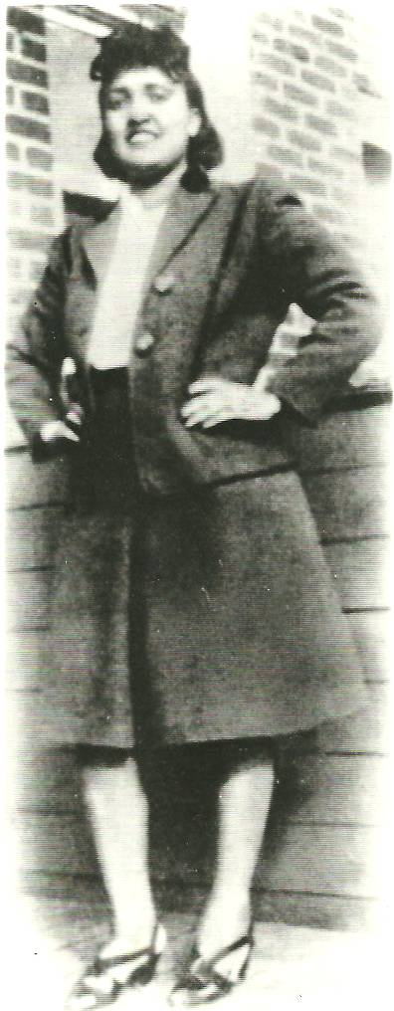
NIH finally invites her family to discuss the use of her extraordinary cells.
By Marc Silver, National Geographic
PUBLISHED AUGUST 17, 2013
Henrietta Lacks was an unwitting donor of cells from her cancerous tumor, which formed the first human cell line used for medical research.
An aggressive strain of cervical cancer took her life in 1951, when she was only 31. But cells harvested from her tumor, without her consent, have lived on ... and on and on.
The best-selling book The Immortal Life of Henrietta Lacks, which features the striking image of Lacks on its cover, tells the story of this African-American woman, her family, and her fast-growing cells, used in over 70,000 medical studies.
"HeLa cells," as they are called, have made vital contributions to the development of drugs for herpes, leukemia, influenza, and Parkinson's disease. The cells have been used in studies on everything from lactose digestion to mosquito mating. "The cells reproduced an entire generation every twenty-four hours, and they never stopped," writes author Rebecca Skloot. Today there are millions, perhaps even billions, of her cells "in small vials on ice."
The latest development in the story: Earlier this year, scientists sequenced Henrietta Lacks's genome and made it public, without asking the family's permission. That is clearly a violation of privacy. But now the National Institutes of Health has taken the important step of inviting two of Lacks's descendants to be part of the HeLa Genome Data Access working group, which considers applications to use the genome. We spoke with Skloot for her perspective on this latest turn in the Lacks saga.

When you wrote the book, could you ever have imagined this latest turn of events: a medical institution inviting the Lacks family to join them in future deliberations?
In my wildest dreams, what I hoped would happen [is that the book would] lead to a big national discussion that would result in scientists and the Lacks family being in the room together talking and making some kinds of decisions about policy. It's an incredible thing to see.
What does this mean to the family?
It's a recognition of what they've been through. Also for them there are some pretty real implications and concerns about questions of privacy. No one ever asked if genes from their family could be released to the public. Beyond that their family has never had a voice in anything having to do with HeLa cells.
Is this a case of racism?
In the '50s it was not like they were targeting [Henrietta Lacks] because of her race. They took samples from anyone they could, including their own families.
In the 1970s, when scientists went back to her children to do research on them-—that's the moment I think race played a significant role. The scientists grew up in an era of segregation, of not having to ever explain things to black people. Laws had changed, segregation was gone, but people hadn't necessarily changed. I think had they been a white family they would have been treated differently.
If any scientists in the '70s had taken time to just say, "Do you have any questions?" they would have realized that the Lacks family didn't know the cells were being used in research, didn't know what a cell was. They thought some part of Henrietta was alive. All this would have come up if someone had just said: "Does anyone have any questions?"

