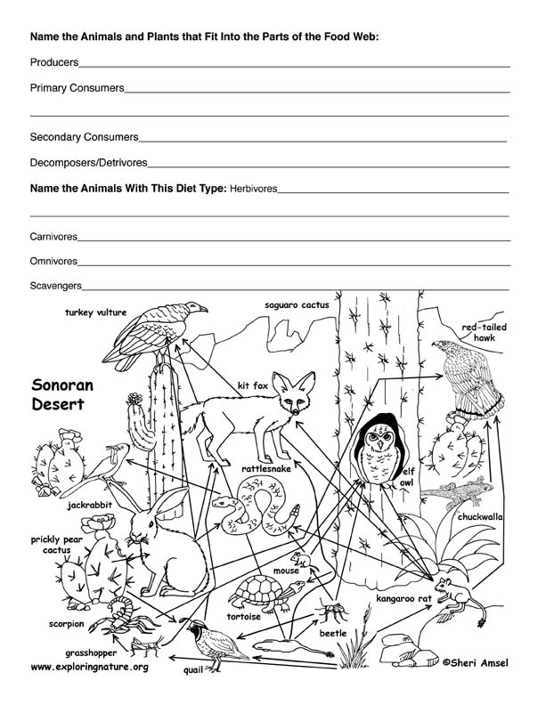
Question: Why do you think the arrows face the direction that they do (What do they represent)?
Food Web
Name _________________________________Per. ___
Definitions
Producers (autotrophs): An organism capable of producing complex organic compounds from simple inorganic molecules through the process of photosynthesis (using light energy) or through chemosynthesis (using chemical energy).
Primary consumers: Any organism that consumes or feeds on autotrophs/producers or decaying matter. (First level of “eaters).”
Secondary consumers: An organism that mostly feeds on primary consumers.
Decomposers/Detritivores: An organism whose ecological function involves recycling of nutrients by performing the natural process of decomposition as it feeds on dead or decaying organisms.

Herbivores: An animal that feeds on only plants
Carnivores: An animal or plant (particularly insect-eating plants) that requires a diet consisting mainly or exclusively of animal tissue through predation or scavenging.
Omnivores: An animal that includes both plants and animals in its normal diet.
Scavengers: An animal that eats carcasses abandoned by predators, digs through trash cans for food etc., true scavengers seldom kill their own prey (but many animals are not exclusively scavengers).

