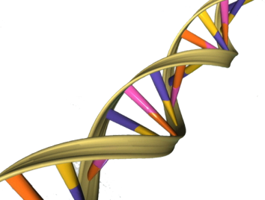
Genetics/DNA Unit Review Name_________________________Per.____
The following will help you prepare for the test this Friday. Use your notebook and textbook to do the following work on a separate sheet of paper.

Cell Division
- What are the differences between mitosis and meiosis? (focus on the following):
  - Which involves somatic cells and which involves gametes?
  - What is the purpose of each type of cell division?
  - Which results in 4 haploid cells and which in 2 diploid cells?
  - Which involves asexual reproduction and which involves sexual reproduction?
Genetics
- Be able to distinguish between Mendel’s three laws
- Understand the following vocabulary words and the relationships between them:
  - Dominant vs. recessive
  - Homozygous vs. heterozygous
  - Purebred vs. hybrid
  - Genotype vs. phenotype
  - Alleles vs. chromosomes vs. genes vs. DNA
- Be able to set-up and complete a punnett square and make predictions about the genotypes and phenotpyes of offspring given information about the parents.
  - For example, if brown eyes are dominant to blue and a heterozygous brown-eyed parent crosses with a blue-eyed parent, determine the likelihood that the couple will have a brown-eyed child.
- Honors Students only: be able to interpret a pedigree
DNA
- What is the structure of DNA (draw and label a section of DNA including):
  - Base-pairs
  - Nucleotides
  - Sugar
  - Phosphate
- What does the term “double-helix” refer to?
- What are the two steps of protein synthesis?
- Describe the process of protein synthesis from the DNA to a Protein including the following vocabulary:
  - Codon d. anticodon g. DNA j. amino acids
  - mRNA e. nucleus h. transcription k. base-pairing
  - tRNA f. nuclear pore i. translation

