Monday, January 8, 2018
Biology Week 1 Day 85

Standard: Mutations
Learning Target: Identify the different types of mutations and their effects through writing Cornell notes, watching a video clip and summarizing.

Essential Question: What can go wrong with DNA? Are the effects harmful or beneficial?

Agenda:
1. Return Papers
2. “The twisting tale of DNA” video
3. Mutation Notes (Cornell). Page 1 of new notebook

Tuesday, January 9, 2018
Biology Week 1 Day 86

Standard: Mutations
Learning Target: Review and summarize Cornell notes, watch a video clip about mutations and identify the different types of mutations by matching key words in definitions to key words in “stories” describing example mutations.

Essential Question: What can go wrong with DNA? Are the effects harmful or beneficial?

Agenda:
1. Review and summarize notes (p. 1)
2. Amoeba Sisters: “Mutations”
2. Mutation Stations activity (p. 2)

Wednesday, January 10, 2018
Biology Week 1 Day 87

Standard: Mutations
Learning Target: Watch a video clip review about mutations and research key information about mutations while completing a “webquest.”

Essential Question: What can go wrong with DNA? Are the effects harmful or beneficial?

Agenda:
1. Teacher’s Pet “mutations” video clip
2. “Mutation Exploration Webquest” (p. 3)

Wednesday, January 10, 2018
Biology Week 1 Day 87
SUB

Standard: Mutations
Learning Target: Read a scientific article, annotate, evaluate and discuss. Watch a video clip about albinism and summarize and write a reflection about a second video clip.

Essential Question: What can go wrong with DNA? Are the effects harmful or beneficial?

Agenda:
- Pinky Article (P. 3)

Thursday, January 11, 2018
Biology Week 1 Day 88

Standard: Mutations
Learning Target: Discuss the Pinky article and associated video clips to check for understanding and then complete a webquest to explore different mutations and their effects.

Essential Question: What can go wrong with DNA? Are the effects harmful or beneficial?

Agenda:
- Pinky Article (P. 3) – Discuss
- Mutation Exploration (webquest) p. 4

Friday, January 12, 2018
Biology Week 1 Day 89

Standard: Mutations
Learning Target: Demonstrate knowledge of mutations by correctly answering warm-up questions and complete a webquest to explore different mutations and their effects.

Essential Question: What can go wrong with DNA? Are the effects harmful or beneficial?

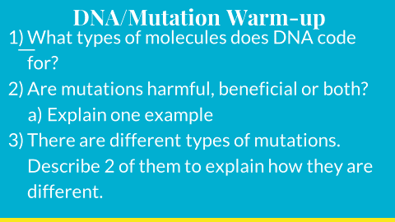
Agenda:
- Warm-up (turn in):

- Mutation Exploration (web quest) p. 4
- Period 6 (started “traits” info on page 5)

Tuesday, January 16, 2018
Biology Week 2 Day 90

Standard: Traits
Learning Target: Identify which traits are common and which are rare by documenting which traits they possess and comparing class data.

Essential Question: What is a trait?

Agenda:
- “Traits” Page 5 (and 6)

Wednesday, January 17, 2018
Biology Week 2 Day 91

Standard: Traits
Learning Target: Write definitions that will be used in solving genetics problems. Write key information about Mendel and his laws.

Essential Question: What is a trait?

Agenda:
- Genetics Vocab (p. 6): Allele, Dominant, Recessive, Heterozygous, Homozygous, Phenotype and Genotype).
- Mendel PowerPoint (p. 7)

Thursday, January 18, 2018
Biology Week 2 Day 92

Standard: Genetics
Learning Target: Write key facts about Mendel and his laws of genetics. Practice making predictions of heredity using Punnett Squares.

Essential Question: What are Mendel’s Laws of heredity?

Agenda:
- Mendel PowerPoint (p. 7)
- SpongeBob Genetics (p. 8): Finish for HW (Per. 1 – quiz version, Periods 5 and 6 regular version)

Friday, January 18, 2018
Biology Week 2 Day 93

Standard: Genetics
Learning Target: Practice making predictions of heredity using Punnett Squares. Use Mendel’s Law of Dominance to determine traits of your Superhero.

Essential Question: What are Mendel’s Laws of heredity?

Agenda:
- SpongeBob Genetics (p. 8): Discuss
- Superhero genetics

Monday, January 22, 2018
Biology Week 3 Day 94

Standard: Genetics
Learning Target: Practice making predictions of heredity using Punnett Squares. Use Mendel’s Law of Dominance to determine traits of your Superhero.

Essential Question: What are Mendel’s Laws of heredity?

Agenda:
- Finish Super heroes (turn in)

Tuesday, January 23, 2018
Biology Week 3 Day 95

Standard: Genetics
Learning Target: Practice making predictions of heredity using Punnett Squares.

Essential Question: What are Mendel’s Laws of heredity?

Agenda:
- Monohybrid Crosses (p. 9)
- Mendel’s Laws Notes (with 16 squares) – p. 10

Wednesday, January 24, 2018
Biology Week 3 Day 96

Standard: Genetics
Learning Target: Practice making predictions of heredity using Punnett Squares.

Essential Question: What are Mendel’s Laws of heredity?

Agenda:
- Dihybrid Crosses (Mice): Page 11

Thursday, January 25, 2018
Biology Week 3 Day 97
COUNSELORS

Standard: Genetics
Learning Target: Work with a counselor to plan for high school and beyond.

Essential Question: What is your 4-year plan?

Agenda:
- 4-year plan (Mr. Mendez periods 1 and 5) (Mr. Mannes period 6).

Friday, January 26, 2018
Biology Week 3 Day 98

Standard: Genetics
Learning Target: Discuss genetic predictions using 2 traits (dihybrids) and write Cornell notes about sex-linked traits.

Essential Question: What are sex-linked traits and how do they differ from regular Punnett squares?

Agenda:
- Discuss p. 11 (Mice)
- P. 12 Sex-linked Traits notes

Monday, January 29, 2018
Biology Week 4 Day 99

Standard: Genetics
Learning Target: Write Cornell notes about sex-linked traits and summarize. Practice making predictions of traits using pedigrees.

Essential Question: What are sex-linked traits and how do they differ from regular Punnett squares?

Agenda:
- Finish Sex-linked traits notes and summarize (p. 12)
- Pedigree Problems (p. 13)

Tuesday, January 30, 2018
Biology Week 4 Day 100

Standard: Genetics
Learning Target: Practice making predictions of traits using pedigrees. Watch a video clip about exceptions to Mendel’s rules and practice problems predicting the outcome of genetic traits that don’t follow Mendel’s rules.

Essential Question: What are the exceptions to Mendel’s Rules?

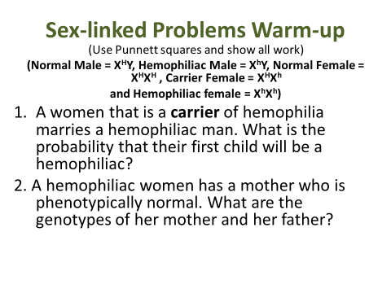
Agenda:
- Warm-up
- Discuss Pedigree Problems (p. 13)
- Amoeba Sister’s (Rebels)
- P. 14 Incomplete and Co-dominance Problems

Wednesday, January 31, 2018
Biology Week 4 Day 101

Standard: Genetics
Learning Target: Practice making predictions of blood types using Punnett Squares.

Essential Question: What are the exceptions to Mendel’s Rules?

Agenda:
- P. 14 Incomplete and Co-dominance Problems

Thursday, February 1, 2018
Biology Week 4 Day 102

Standard: Genetics
Learning Target: Review for the test and practice making predictions of traits displaying co-dominance, incomplete dominance and those that follow Mendel’s Laws.

Essential Question: What are the exceptions to Mendel’s Rules?

Agenda:
- Whiteboard Review

Friday, February 2, 2018
Biology Week 4 Day 103

Standard: Genetics
Learning Target: Demonstrate knowledge of genetics by scoring proficient or advanced on the test.

Essential Question: What are Mendel’s Laws?

Agenda:
- Genetics Test

Monday, February 5, 2018
Biology Week 5 Day 104

Standard: Biotechnology/Genetic Engineering
Learning Target: Understand how DNA can be manipulated through writing key facts and summarizing a PowerPoint and video clips.

Essential Question: How can DNA be manipulated?

Agenda:
- Biotechnology/Genetic Engineering PPT (p. 15) 15 facts
- Summary

Tuesday, February 6, 2018
Biology Week 5 Day 105

Standard: Biotechnology/Genetic Engineering
Learning Target: Understand how DNA can be manipulated through writing key facts and summarizing a PowerPoint and video clips. Create a genetically modified organism and an advertisement to “sell” it.

Essential Question: How can DNA be manipulated?

Agenda:
- Biotechnology/Genetic Engineering PPT (p. 15) 15 facts
- Summary
- GMO advertisement

Wednesday, February 7, 2018
Biology Week 5 Day 106
(5th Period to counseling presentation)
Standard: Biotechnology/Genetic Engineering
Learning Target: Understand how DNA can be manipulated through writing key facts and summarizing a PowerPoint and video clips. Create a genetically modified organism and an advertisement to “sell” it.

Essential Question: How can DNA be manipulated?

Agenda:
- GMO advertisements

Thursday, February 8, 2018
Biology Week 5 Day 107
Standard: Biotechnology/Genetic Engineering
Learning Target: Understand how DNA can be manipulated through writing key facts and summarizing a PowerPoint and video clips. Create a genetically modified organism and an advertisement to “sell” it.

Essential Question: How can DNA be manipulated?

Agenda:
- Present GMO advertisements (competition)!!!

Friday, February 9, 2018
Biology Week 5 Day 108
Standard: Biotechnology/Genetic Engineering
Learning Target: Read and annotate and article and then read a different scientific article to summarize in a brief presentation 1 disease that gene therapy is being studied to cure.

Essential Question: Was the use of Henrietta’s cells justified?

Agenda:
- Read Henrietta Lacks
- Annotate article
- Read scientific info and make a presentation
- Present
- Reflect

Monday, February 12, 2018
Biology Week 6 Day 109
Standard: Biotechnology/Genetic Engineering
Learning Target: Read a scientific article to summarize in a brief presentation 1 disease that gene therapy is being studied to cure.

Essential Question: Was the use of Henrietta’s cells justified?

Agenda:
- Read scientific info and make a presentation
- Present
- Reflect
- Intro to Earth History

Tuesday, February 13, 2018
Biology Week 6 Day 110
Standard: Earth History/Evolution
Learning Target: Watch a video clip to visualize earth history and collaboratively make a timeline to represent time periods and key events.

Essential Question: What biological and geological changes have occurred in earth’s history?

Agenda:
- Intro to Earth History (football analogy clip)
- Earth History Timeline Project

Wednesday, February 14, 2018
Biology Week 6 Day 111
Standard: Earth History/Evolution
Learning Target: Collaboratively make a timeline to represent time periods and key events.

Essential Question: What biological and geological changes have occurred in earth’s history?

Agenda:
- Earth History Timeline Project

Thursday, February 15, 2018
Biology Week 6 Day 112
Standard: Earth History/Evolution
Learning Target: Collaboratively make a timeline to represent time periods and key events.

Essential Question: What biological and geological changes have occurred in earth’s history?

Agenda:
- Earth History Timeline Project – last day

Tuesday, February 20, 2018
Biology Week 7 Day 113
Standard: Adaptations/Evolution
Learning Target: Watch a video clip to review adaptations in plants and animals and then collaboratively discuss/write and draw an example of a behavioral and a physical adaptation. Complete a circle map for evolution adding ideas from brainstorming and then facts from a video clip.

Essential Question: What are adaptations and how do they help organisms survive?

Agenda:
- Adaptation video clip
- Adaptation post-its
- Natural Selection PowerPoint (p. 17)

Wednesday, February 21, 2018
Biology Week 7 Day 114
Standard: Adaptations/Evolution
Learning Target: Watch video clips, write key information and discuss how natural selection can lead to evolution.

Essential Question: How does evolution occur in populations?

Agenda:
- Evolution warm-up (true or false)?
- Natural Selection PowerPoint (p. 17)

Thursday, February 22, 2018
Biology Week 7 Day 115
Standard: Adaptations/Evolution
Learning Target: Watch video clips, write key information and discuss how natural selection can lead to evolution. Roll dice to randomly determine the environment for a made-up creature and then make up a creature that has adaptations for the random environment.

Essential Question: How does evolution occur in populations?

Agenda:
- Natural Selection PowerPoint (p. 17)
- “Design-a-creature” activity

Friday, February 23, 2018
Biology Week 7 Day 116
Standard: Adaptations/Evolution
Learning Target: Roll dice to randomly determine the environment for a made-up creature and then make up a creature that has adaptations for the random environment.

Essential Question: How does evolution occur in populations?

Agenda:
- Finish “Design-a-creature” activity

Monday, February 26, 2018
Biology Week 8 Day 117
Standard: Adaptations/Evolution
Learning Target: Read, analyze and discuss a scientific article about the evolution of squid eyes.

Essential Question: How has the Sperm Whale influenced the evolution of Giant Squid eyes?

Agenda:
- Read article
- Mark/annotate (p. 18)
- Analysis questions (p. 18)

Tuesday, February 27, 2018
Biology Week 8 Day 118
Standard: Adaptations/Evolution
Learning Target: Consider structure and function as you explore the squid. Use a microscope to look closely at some of the structures.

Essential Question: How are squids adapted to their environment?

Agenda:
- Structure/Adaptation Chart
- Squid Dissection
- Clean-up

Wednesday, February 28, 2018
Biology Week 8 Day 119
Standard: Adaptations/Evolution
Learning Target: Simulate microevolution of Pepper moth populations and discuss evolution through viewing examples in a PowerPoint.

Essential Question: How do Pepper Moth populations demonstrate natural selection?

Agenda:
- Moth Simulation
- P. 19 PowerPoint

Thursday, March 1, 2018
Biology Week 8 Day 120
Standard: Adaptations/Evolution
Learning Target: Clarify understanding of natural selection by answering practice questions and writing key facts from a PowerPoint.

Essential Question: How do Pepper Moth populations demonstrate natural selection?

Agenda:
- Misconception Warm-up
- P. 19 PowerPoint

Friday, March 2, 2018
Biology Week 8 Day 121

Standard: Evolution
Learning Target: Students will write key facts about the evolution of dogs while watching “Dogs Decoded.”

Essential Question:
How have dogs evolved?
Agenda:
1. “Dogs Decoded”

Monday, March 5, 2018
Biology Week 9 Day 122

Standard: Evolution
Learning Target: Students will answer a warm-up question about the coevolution of dogs and humans and will then write key facts and summarize information from a PowerPoint about evolution. Finally, students will compare amino acid information to determine the relatedness of species.

Essential Question:
How have dogs and humans co-evolved?
Agenda:
- Dog and human coevolution warm-up
- Finish p. 19 (Theory of Evolution PPT)
- Amino Acid Comparisons (p. 20)

Tuesday, March 6, 2018
Biology Week 9 Day 123
(Safety Meeting– 1st period to theater)

Standard: Evolution
Learning Target: Different for Every Period

Essential Question: What types of evidence exists for evolution?
Agenda:
- Period 1: to theater for Safety meeting
- Period 5: Evolve, “Eyes” video with guide
- Period 6: Work on Honors Projects (video or PowerPoint or Paper).

Wednesday, March 7, 2018
Biology Week 9 Day 124
Standard: Evolution
Learning Target: Discuss slides and write key facts about speciation.

Essential Question: How do new species evolve?
Agenda:
- Speciation PowerPoint (p. 21)

Thursday, March 8, 2018
Biology Week 9 Day 125
Standard: Evolution
Learning Target: Predict the types of foods different birds eat based on the shapes of their beaks, watch a documentary about the long-term study of the evolution of finches on the Galapagos Islands and discuss slides and write key facts about speciation.

Essential Question: How do new species evolve?
Agenda:
- Bird Beak warm-up
- HHMI “Beak of the Finch” video
- Speciation PowerPoint (p. 21)

Friday, March 9, 2018
Biology Week 9 Day 126
Standard: Evolution
Learning Target: Each class is different today

Essential Question: Each class is different today

Agenda:
1st period to theater (“This I Believe)
5th period Evolve: “Size” Video
6th period: work on Honors Projects

Monday, March 12, 2018
Biology Week 10 Day 127
Standard: Evolution
Learning Target: Pair organisms into a chart to represent convergent evolution. Write key facts from a PowerPoint on Speciation.
Essential Question: What is convergent evolution and how is it related to speciation?
Agenda:
- Convergent evolution chart: p. 22
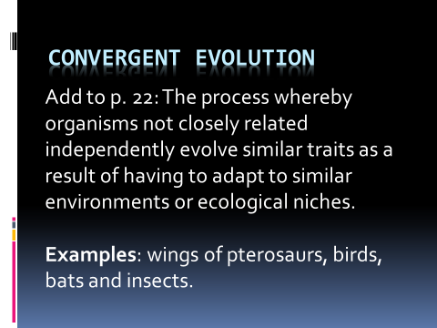
- P. 21 Speciation PPT.

Tuesday, March 13, 2018
Biology Week 10 Day 128
Standard: Students know variation within a species increases the likelihood that at least some members of a species will survive under changed environmental conditions.

Learning Target: Students will read a scientific article about the evolution of color in lizards and will then watch a video clip about the research and write a summary of the scientific research and how it represents evolution in action.

Essential Questions: How have the lizards evolved to “fit” their environment?

Agenda:
1) p. 23: Lizard article (number paragraphs and read)
2) “Random Read” (1 reads, 1 summarizes)
3) Summarize (p. 23)

Wednesday, March 14, 2018
Biology Week 10 Day 129
Standard: Students know variation within a species increases the likelihood that at least some members of a species will survive under changed environmental conditions.

Learning Target: Distinguish between the different patterns of evolution by answering different questions about convergent and divergent evolution, homologous structures and analogous structures.

Essential Questions: What are the different patterns of evolution and how can you recognize them?

Agenda:
1) p. 24: “Patterns of Evolution”

Thursday, March 15, 2018
Biology Week 10 Day 130
Standard: Students know variation within a species increases the likelihood that at least some members of a species will survive under changed environmental conditions.

Learning Target: Practice interpreting phylogenetic trees using primates and answer questions about human evolution through watching video clips.

Essential Questions: What is evidence for evolution and what does it tell us about human evolution?

Agenda:
- Stated Clearly (Evidence for Evolution)
- Human Evolution (p. 25)

Friday, March 16, 2018
Biology Week 10 Day 131
Standard: Students know variation within a species increases the likelihood that at least some members of a species will survive under changed environmental conditions.

Learning Target: Write about how the pepper moths explain how evolution works. Answer questions about human evolution through watching video clips.

Essential Questions: What is evidence for evolution and what does it tell us about human evolution?

Agenda:
- Short Cycle Review: Explain how the pepper moths explain how evolution works?
- Human Evolution (p. 25) (Questions 5-11).

Monday, March 19, 2018
Biology Week 11 Day 132
Standard: Students know variation within a species increases the likelihood that at least some members of a species will survive under changed environmental conditions.

Learning Target: Demonstrate understanding of natural selection by scoring well on the district short cycle.

Essential Questions: How do pepper moths demonstrate natural selection?

Agenda:
- Short Cycle
- Check notebooks in preparation for the test tomorrow.

Tuesday, March 20, 2018
Biology Week 11 Day 133
Standard: Students know variation within a species increases the likelihood that at least some members of a species will survive under changed environmental conditions.

Learning Target: Demonstrate understanding of natural selection by scoring well on the open notebook test.

Essential Questions: How do organisms evolve?

Agenda:
- Notebook Test (Evolution)

Wednesday, March 21, 2018
Biology Week 11 Day 134
Standard: Students know variation within a species increases the likelihood that at least some members of a species will survive under changed environmental conditions.

Learning Target: Qualitatively and quantitatively collect data from different skulls to determine their correct placement on a phylogenetic tree. Calculate the ratio of foramen magnum distances to skull length and graph against cranial capacity to group species. Discuss results and justify decisions in writing.

Essential Questions: Can you collect data to properly identify species by just their skulls?

Agenda:
- “Mystery of the Skulls” lab Day 1

Thursday, March 22, 2018
Biology Week 11 Day 135
Standard: Students know variation within a species increases the likelihood that at least some members of a species will survive under changed environmental conditions.

Learning Target: Qualitatively and quantitatively collect data from different skulls to determine their correct placement on a phylogenetic tree. Calculate the ratio of foramen magnum distances to skull length and graph against cranial capacity to group species. Discuss results and justify decisions in writing.

Essential Questions: Can you collect data to properly identify species by just their skulls?

Agenda:
- “Mystery of the Skulls” lab Day 2

Friday, March 23, 2018
Biology Week 11 Day 136
Standard: Students know variation within a species increases the likelihood that at least some members of a species will survive under changed environmental conditions.

Learning Target: Qualitatively and quantitatively collect data from different skulls to determine their correct placement on a phylogenetic tree. Calculate the ratio of foramen magnum distances to skull length and graph against cranial capacity to group species. Discuss results and justify decisions in writing.

Essential Questions: Can you collect data to properly identify species by just their skulls?

Agenda:
- “Mystery of the Skulls” lab Day 3 - Analysis

Monday, April 9, 2018
Biology Week 12 Day 137
Standard: Students know variation within a species increases the likelihood that at least some members of a species will survive under changed environmental conditions.

Learning Target: Connect evolutionary concepts to information in a documentary while writing key facts.

Essential Questions: How did shape evolve (periods 1 & 5)? How did eyes evolve (per. 6)?
Agenda:

- Periods 1 & 5: Evolve “Shape” and turn in Hominin Lab
Period 6: Evolve “Eyes”

Tuesday, April 10, 2018
Biology Week 12 Day 138
Standard: Ecology

Learning Target: Students will organize groups of living things into a logical hierarchy and will write key facts from a PowerPoint about ecology (the interactions between organisms and their environment).

Essential Questions: How do organisms interact with each other and with their surroundings?

Agenda:
- Levels of Organization (p. 27)
- Ecology PowerPoint (p. 28)

Wednesday, April 11, 2018
Biology Week 12 Day 139
Standard: Ecology

Learning Target: Students will categorize pictures into abiotic or biotic and then will write key facts from a PowerPoint about ecology (the interactions between organisms and their environment).

Essential Questions: How do organisms interact with each other and with their surroundings?

Agenda:
- Abiotic vs. Biotic (p. 29)
- Ecology PowerPoint (p. 28)

Thursday, April 12, 2018
Biology Week 12 Day 140
BLOCK SCHEDULE (1, 3, 5)
Standard: Ecology

Learning Target: Read and analyze a scientific article about Sahara Mustard. Collaboratively research an invasive species, create a slideshow and present to peers.

Essential Questions: What makes an introduced species invasive?

Agenda:
- Sahara Mustard Article (p. 30)
- Ted-Ed: “Invasive Species”
- Invasive Species Projects

Friday, April 13, 2018
Biology Week 12 Day 141
BLOCK SCHEDULE (2, 4, 6)
Standard: Ecology

Learning Target: Read and analyze a scientific article about Sahara Mustard. Collaboratively research an invasive species, create a slideshow and present to peers.

Essential Questions: What makes an introduced species invasive?

Agenda:
- Sahara Mustard Article (p. 30)
- Ted-Ed: “Invasive Species”
- Invasive Species Projects

Monday, April 16, 2018
Biology Week 13 Day 142

Standard: Ecology

Learning Target: Collaboratively research an invasive species, create a slideshow and present to peers.

Essential Questions: What makes an introduced species invasive?

Agenda:
- Invasive Species Presentations

Tuesday, April 17, 2018
Biology Week 13 Day 143

Standard: Ecology

Learning Target: Present invasive species research to peers.

Essential Questions: What makes an introduced species invasive?

Agenda:
- Invasive Species Presentations
- “Top 10 Invasive Species” video clip

Wednesday, April 18, 2018
Biology Week 13 Day 144

Standard: Ecology

Learning Target: Write key information about invasive species and their effects on ecosystems and on economy.

Essential Questions: What are concerns about invasive species? What research is being done to combat invasives?

Agenda:
- Invasive Species Presentations (Period 1 still finish)
- “Invaders” – with video guide (turn in)

Thursday, April 19, 2018
Biology Week 13 Day 145

Standard: Ecology

Learning Target: Write key information about invasive species and their effects on ecosystems and on economy.

Essential Questions: What are concerns about invasive species? What research is being done to combat invasives?

Agenda:
- Invasive Species Warm-up (Quiz)
- “Invaders” – with video guide (turn in) – Per. 1 finish
- P. 28 Ecology PowerPoint Continued

Friday, April 20, 2018
Biology Week 13 Day 146

Standard: Ecology

Learning Target: Create a Haiku about Earth to celebrate Earth Day and consider reasons why the earth is important.

Essential Questions: Why should we protect the earth? How can you help?

Agenda:
- Earth Day Haiku

Monday, April 23, 2018
Biology Week 14 Day 147

Standard: Ecology

Learning Target: Understand key ecological concepts through writing, discussion, and watching video clips.

Essential Questions: What are the different types of relationships organisms have with each other?

Agenda:
- P. 28 Ecology PowerPoint (symbiosis)

Tuesday, April 24, 2018
Biology Week 14 Day 148

Standard: Ecology

Learning Target: Understand key ecological concepts through writing, discussion, and watching video clips.

Essential Questions: What are the different types of relationships organisms have with each other?

Agenda:
- P. 28 Ecology PowerPoint

Wednesday, April 25, 2018
Biology Week 14 Day 149

Standard: Ecology

Learning Target: Critically listen to a TedTalk about the management steps taken to save the California Condor from extinction. List management steps and read a scientific article about another endangered vulture species occupying the same niche.

Essential Questions: Is it important to save vulture species? How is recognizing their niche important in making the decision?

Agenda:
- Ted Talk: California Condor (list 8 steps taken)
- Read “Vulture” article

Thursday, April 26, 2018
Biology Week 14 Day 150

Standard: Ecology

Learning Target: Read a scientific article about another endangered vulture species occupying the same niche. Answer analysis questions and design a management plan to protect the vultures.

Essential Questions: Is it important to save vulture species? How is recognizing their niche important in making the decision?

Agenda:
- Read “Vulture” article
- Answer analysis questions
- P. 28 Ecology PowerPoint

Friday, April 27, 2018
Biology Week 14 Day 151

Standard: Ecology

Learning Target: Honors students will work on their final projects and CP students will review case studies of environmental water issues. Students will write about the causes of the issues and possible solutions.

Essential Questions: What are some environmental issues related to water and what are possible causes and solutions?

Agenda:
- Periods 1 and 5: Finish Ecology PPT (p. 28)
Period 6: Honor’s Projects
- Periods 1 and 5: Strange Days on Planet Earth “Troubled Waters”

Monday, April 30, 2018
Biology Week 15 Day 152
CHROMEBOOK PICK-UP DAY
Standard: Ecology

Learning Target: Explore case studies of environmental water issues and write about the causes and possible solutions.

Essential Questions: What are some environmental issues related to water and what are possible causes and solutions?

Agenda:
- Chromebook Pick-up
- Period 6: Finish p. 28 PPT
Periods 1 and 5: Strange Days on Planet Earth “Troubled Waters”

Tuesday, May 1, 2018
Biology Week 15 Day 153

Standard: Ecology

Learning Target: Explore case studies of environmental water issues and write about the causes and possible solutions.

Essential Questions: What are some environmental issues related to water and what are possible causes and solutions?

Agenda:
- Period 6: Finish p. 28 PPT
Periods 1 and 5: Finish Strange Days on Planet Earth “Troubled Waters”
- P. 32 Carbon Cycle

Wednesday, May 2, 2018
Biology Week 15 Day 155

Standard: Ecology

Learning Target: Explore case studies of environmental water issues and write about the causes and possible solutions.

Essential Questions: What are some environmental issues related to water and what are possible causes and solutions?

Agenda:
- Ecology Reading Packets (p. 11-22): Read, highlight key information (definitions and answers to questions), complete all of the tasks in the margins except for the “Study Coach” sections, the “Foldables” and the “Picture This” on pages 18, 20 and 22.

Thursday, May 3, 2018
Biology Week 15 Day 156

Standard: Ecology

Learning Target: Explore case studies of environmental water issues and write about the causes and possible solutions.

Essential Questions: What are some environmental issues related to water and what are possible causes and solutions?

Agenda:
- Ecology Reading Packets (p. 11-22): Read, highlight key information (definitions and answers to questions), complete all of the tasks in the margins except for the “Study Coach” sections, the “Foldables” and the “Picture This” on pages 18, 20 and 22.
- Notebook “Walk-through” for Notebook Check #9
- Nitrogen “Background” info. for lab

Friday, May 4, 2018
Biology Week 15 Day 157

Standard: Biodiversity is the sum total of different kinds of organisms and is affected by alteration of habitats.
Learning Targets:
Essential Questions: How does nitrogen cycle through an ecosystem and why is it important?
Agenda:
  - Nitrogen Modeling (Lab) – turn in
  - Conclusions (p. 31)
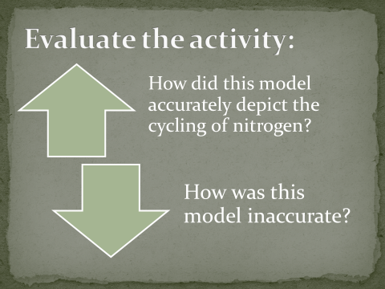
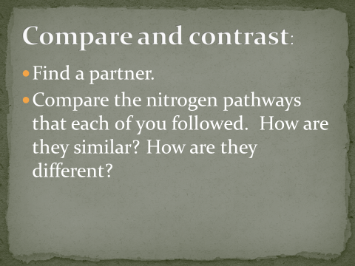

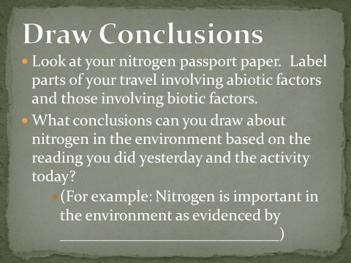
Monday, May 7, 2018
Biology Week 16 Day 158
BLOCK SCHEDULE (1, 3, 5)

Standard: Biodiversity is the sum total of different kinds of organisms and is affected by alteration of habitats.
Learning Targets: Research an endangered species to learn about its niche, the reasons for its listing and create a comprehensive Management Plan and PSA.
Essential Questions: Why is “your” species endangered? Can it be protected or is it too late?
Agenda:
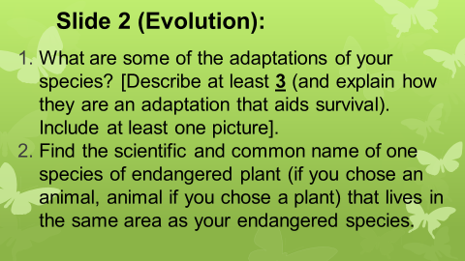
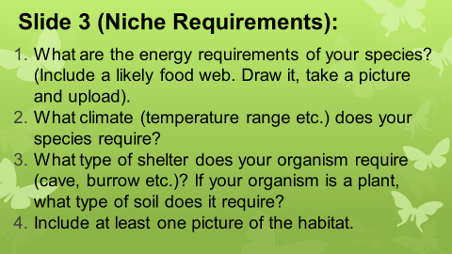
    - Endangered Species Project (Slides 1-3)
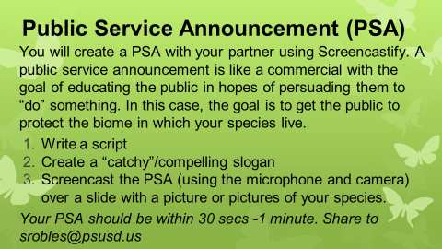
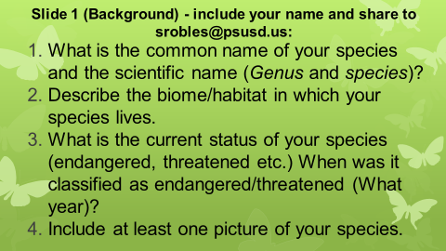
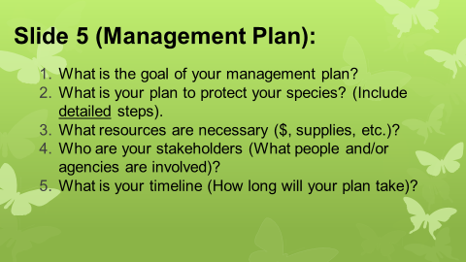
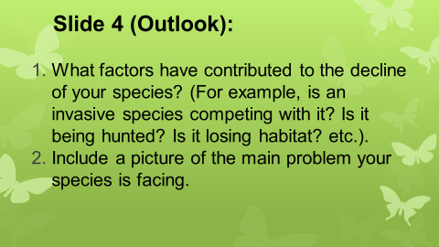

Tuesday, May 8, 2018
Biology Week 16 Day 159
BLOCK SCHEDULE (2, 4, 6)

Standard: Biodiversity is the sum total of different kinds of organisms and is affected by alteration of habitats.
Learning Targets: Research an endangered species to learn about its niche, the reasons for its listing and create a comprehensive Management Plan and PSA.
Essential Questions: Why is “your” species endangered? Can it be protected or is it too late?
Agenda:
      - Endangered Species Project (Slides 1-3)

Wednesday, May 9, 2018
Biology Week 16 Day 160

Standard: Biodiversity is the sum total of different kinds of organisms and is affected by alteration of habitats.
Learning Targets: Research an endangered species to learn about its niche, the reasons for its listing and create a comprehensive Management Plan and PSA.
Essential Questions: Why is “your” species endangered? Can it be protected or is it too late?
Agenda:

1. Endangered Species Project (Slides 4-6)

Thursday, May 10, 2018
Biology Week 16 Day 161
BLOCK SCHEDULE (1, 3, 5)

Standard: Biodiversity is the sum total of different kinds of organisms and is affected by alteration of habitats.
Learning Targets: Research an endangered species to learn about its niche, the reasons for its listing and create a comprehensive Management Plan and PSA.
Essential Questions: Why is “your” species endangered? Can it be protected or is it too late?
Agenda:

1. Endangered Species Project (Slides 4-6)

Friday, May 11, 2018
Biology Week 16 Day 162
BLOCK SCHEDULE (2, 4, 6)

Standard: Biodiversity is the sum total of different kinds of organisms and is affected by alteration of habitats.
Learning Targets: Research an endangered species to learn about its niche, the reasons for its listing and create a comprehensive Management Plan and PSA.
Essential Questions: Why is “your” species endangered? Can it be protected or is it too late?
Agenda:

1. Peer Review (“Honors Projects”):
- Is the coverage of the topic scientific?
- Does there seem to be any plagiarism?
- Are there in-text citations (for the papers)?
- Commendations:
- Recommendations:

- Endangered Species Project (Slides 4-6)
  - PSA Google Classroom Code for 6th period: v0qbpw

Monday, May 14, 2018
Biology Week 17 Day 163
BLOCK SCHEDULE (1, 3, 5)

Standard: Biodiversity is the sum total of different kinds of organisms and is affected by alteration of habitats.
Learning Targets: Research an endangered species to learn about its niche, the reasons for its listing and create a comprehensive Management Plan and PSA.
Essential Questions: Why is “your” species endangered? Can it be protected or is it too late?
Agenda:
  - Screencast PSA
  - Ecology Packets (p. 23-25, 35-39 and 40-42): highlight key info and complete all tasks except for “Foldables” and “Study Coach”

Tuesday, May 15, 2018
Biology Week 17 Day 164
BLOCK SCHEDULE (2, 4, 6)

Standard: Biodiversity is the sum total of different kinds of organisms and is affected by alteration of habitats.
Learning Targets: Research an endangered species to learn about its niche, the reasons for its listing and create a comprehensive Management Plan and PSA.
Essential Questions: Why is “your” species endangered? Can it be protected or is it too late?
Agenda:
  - Screencast PSA
  - Ecology Packets (p. 23-25, 35-39 and 40-42): highlight key info and complete all tasks except for “Foldables” and “Study Coach”

Wednesday, May 16, 2018
Biology Week 17 Day 165
Sub (per. 1 only)

Standard: Biodiversity is the sum total of different kinds of organisms and is affected by alteration of habitats.
Learning Targets: Research an endangered species to learn about its niche, the reasons for its listing and create a comprehensive Management Plan and PSA.
Essential Questions: Why is “your” species endangered? Can it be protected or is it too late?
Agenda:
1. Ecology Packets (Finish)!! Pages 43-54 (Highlight key info and complete all tasks except Foldables, Study Coach and the “Picture This” on pages 45 and 48).

Thursday, May 17, 2018
Biology Week 17 Day 166
BLOCK SCHEDULE (1, 3, 5)

Standard: Biodiversity is the sum total of different kinds of organisms and is affected by alteration of habitats.
Learning Targets: Research an endangered species to learn about its niche, the reasons for its listing and create a comprehensive Management Plan and PSA.
Essential Questions: Why is “your” species endangered? Can it be protected or is it too late?
Agenda:
1. Ecology Packets (Finish)!! Pages 43-54 (Highlight key info and complete all tasks except Foldables, Study Coach
2. Finish any missing work (and vote on Earth Day posters)
3. p. 33: Climate Change and Human Health notes (8 questions and answers).

Friday, May 19, 2018
Biology Week 17 Day 167
BLOCK SCHEDULE (2, 4, 6)

Standard: Biodiversity is the sum total of different kinds of organisms and is affected by alteration of habitats.
Learning Targets: Research an endangered species to learn about its niche, the reasons for its listing and create a comprehensive Management Plan and PSA.
Essential Questions: Why is “your” species endangered? Can it be protected or is it too late?
Agenda:
1. Ecology Packets (Finish)!! Pages 43-54 (Highlight key info and complete all tasks except Foldables, Study Coach
2. Finish any missing work (and vote on Earth Day posters)
3. p. 33: Climate Change and Human Health notes (8 questions and answers).

Monday, May 21, 2018
Biology Week 18 Day 168
Sub Day

Standard: Biodiversity is the sum total of different kinds of organisms and is affected by alteration of habitats.
Learning Targets: Watch case studies of some endangered species and document why they are currently endangered.
Essential Questions: What are different factors causing the loss of biodiversity?
Agenda:
1. “Endangered Species: Don’t Say Goodbye” with video guide

Tuesday, May 22, 2018
Biology Week 18 Day 169

Standard: Biodiversity is the sum total of different kinds of organisms and is affected by alteration of habitats.
Learning Targets: Demonstrate knowledge of ecology by scoring well on a test.
Essential Questions: What are different factors causing the loss of biodiversity?
Agenda:
1. Ecology Test

Wednesday, May 23, 2018
Biology Week 18 Day 170

Standard: Ecology/Health
Learning Targets: Discuss climate change and the effects on human health.
Essential Questions: What are some of the health effects of climate change on humans and what are some things that we can do to slow climate change?
Agenda:
1. Finished p. 33 (climate change)

Thursday, May 24, 2018
Biology Week 18 Day 171

Standard: Health
Learning Targets:
Essential Questions:
Agenda:

Period 1:
1) Finish Endangered Species with video guide
2) EdPuzzle 1: (Viruses vs. Bacteria)
3) Virus/Bacteria Double Bubble (p. 35) – skip p. 34 for now
4) EdPuzzle 2 (HIV)

Period 5: STD PowerPoint (p. 34)

Period 6: STD PowerPoint (p. 34)

Friday, May 25, 2018
Biology Week 18 Day 172

Standard: Health
Learning Targets:
Essential Questions:
Agenda:

Period 1: STD PowerPoint (p. 34)

Periods 5 and 6:
1) EdPuzzle 1: (Viruses vs. Bacteria)
2) Virus/Bacteria Double Bubble (p. 35)
3) EdPuzzle 2 (HIV)

Tuesday, May 29, 2018
Biology Week 19 Day 173

Standard: Health
Learning Targets:
Essential Questions:
Agenda:

1.) Finish STD PowerPoint (p. 34)
2) Return papers/discuss ecology tests

Wednesday, May 30, 2018
Biology Week 19 Day 174

Standard: Health
Learning Targets: Model the spread of HIV through a population by swapping “body fluids” with classmates and then tracing back to find “patient zero.”
Essential Questions:
Agenda:

1.) “Spread of Disease Lab” – turn in disease “tree”

Thursday, May 31, 2018
Biology Week 19 Day 175

Standard: Health
Learning Targets: Determine body fluids associated with different activities and discuss the level of risk for spreading STD’s.
Essential Questions: How can the spread of STD’s be prevented?
Agendas:
- “Actions, Fluids and Risks” (p. 36).

