Adaptation Lesson Name______________________________
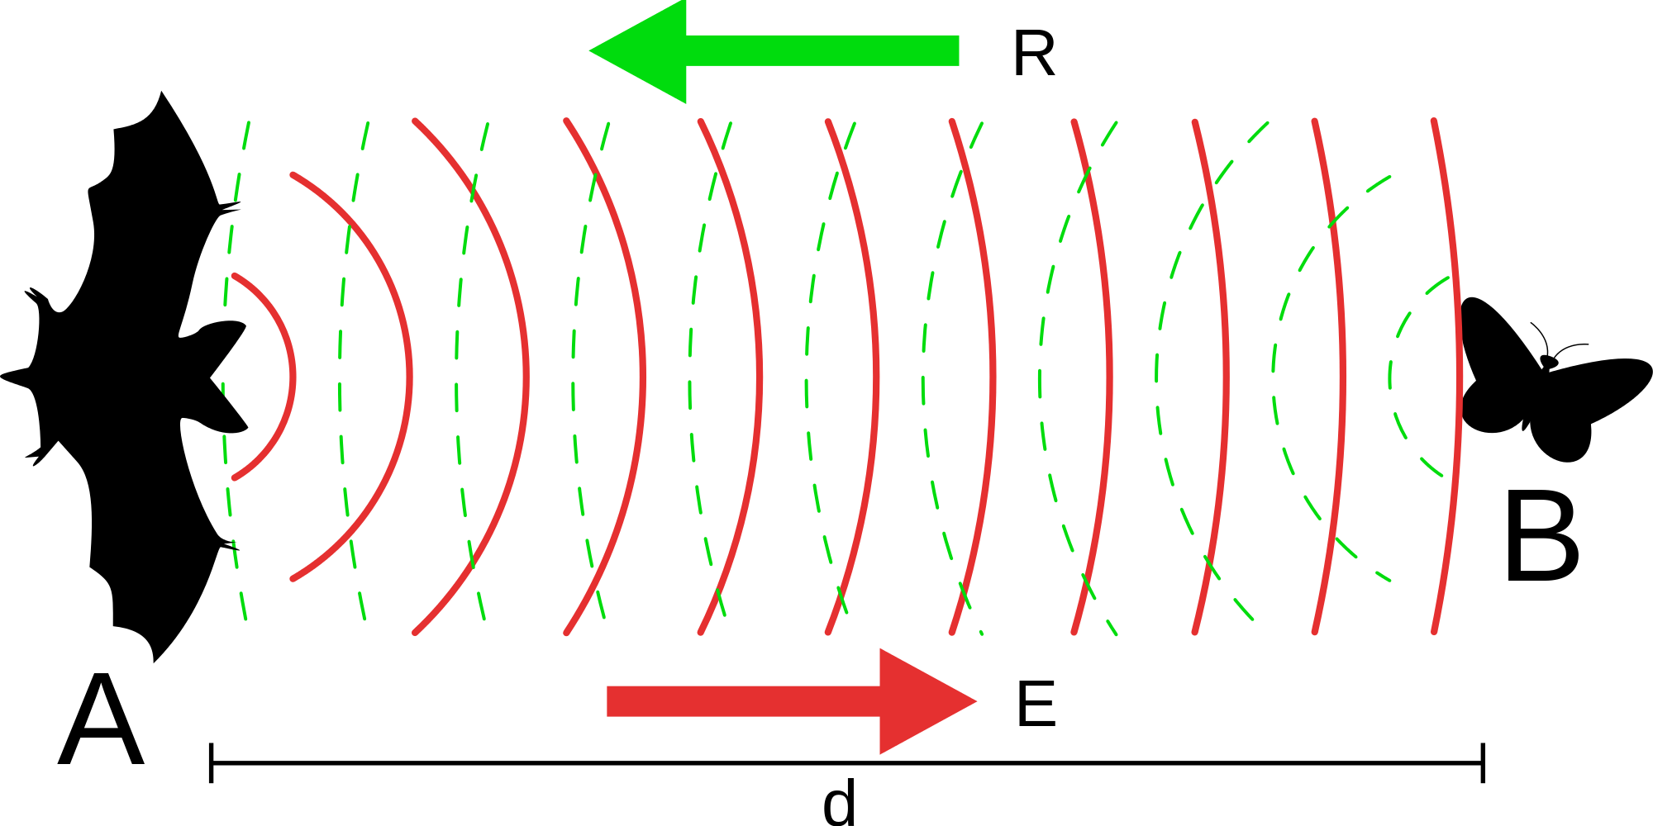

Go to: http://evolution.berkeley.edu/evolibrary/article/evo_31

1. Define Adaptation:

2. What are the 3 different forms of adaptations?

3. What are three examples of adaptations and explain how they would help the organism survive.

4. What is a vestigial organ? Explain why it would NOT be considered an adaptation.

5. Watch the video on the “evolution of sex.” Write a summary that also answers the essential question, “How can sex contribute to the survival of a species?”

