Researchers puzzled as climate change proves beneficial to redwood growth

By San Jose Mercury News, adapted by Newsela staff
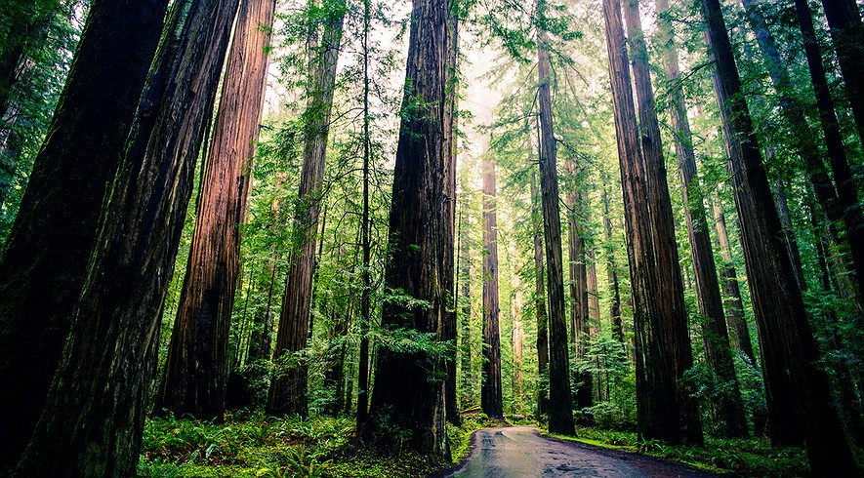
SAN JOSE, Calif. — Climate change is melting glaciers, worsening droughts and raising sea levels around the world.
But when it comes to the ancient redwood trees on the U.S. West Coast, which scientists have worried may be at risk as the planet heats up, global warming may actually be helping, at least for now, according to new research released Wednesday, Aug. 14.

“We’re not seeing any evidence of declining growth rates,” said Steve Sillett, a forestry professor and nationally known redwoods expert. “In fact, a lot of the sites are exhibiting increasing rates of growth over the last 100 years.”

It may be that the trees prefer warmer temperatures, or that they are benefiting from more sunlight, a longer growing season, or even decades of fire suppression. Or they might even be responding well to higher levels of carbon dioxide in the atmosphere.

Nobody knows yet.

"They Are Growing Vigorously"

But Sillett and other researchers working on an ambitious, four-year study found that growth rates of coast redwoods and giant sequoia trees in California’s old-growth forests increased during the 20th century. At the same time, other parts of the Earth’s environment — from polar bears to coral reefs — suffered from climate change.

Redwood forests near the California-Oregon border have seen the largest surge in wood production. The discovery has generated guarded optimism among conservationists.

“Redwoods are an incredibly hopeful story in the midst of seemingly catastrophic environmental change around us,” said Emily Burns, science director for Save the Redwoods League. The San Francisco nonprofit group is sponsoring the research. “They are growing vigorously.”

Water remains a concern, however. A study published three years ago found that the amount of fog in redwood areas along California’s coast has fallen 33 percent over the past century. But so far that lack of fog may have allowed more sunlight to reach the trees, said Todd Dawson, a lead scientist on the team.
When it comes to giant sequoias, the biological cousins of coast redwoods that live in the Sierra Nevada mountain range, warmer weather may have increased the growing season by reducing the number of days they are under snow. More research is needed in the coming years to test both theories, the researchers said.
The news is good now. But some scientists working on the project worry that conditions could worsen for the trees if rising temperatures cause precipitation in California to decrease significantly over the coming decades.

Some Here Since Medieval Times

“There’s a tipping point,” Dawson said. “As we go into warmer and drier times, particularly with snowpacks on the decline — which means less water for giant sequoias — we’re concerned that this growth surge is probably not going to be sustainable.”

The researchers are doing groundbreaking work in the world’s tallest and largest trees. They have climbed dozens of immense redwoods and sequoias at 13 locations as part of the $2.5 million project.

Many of the trees were growing before Europe’s medieval cathedrals were built. The scientists fitted trees with sensors to measure temperature, humidity, rain, fog, light, wind and barometric pressure. They used lasers to help measure the heights of trees, complex studies of isotopes to re-create the weather from centuries ago, and core samples to learn the ages and growth rates of the trees.

Sillett’s pioneering research, climbing redwoods 300 feet tall and higher, was featured in the 2007 book “The Wild Trees.” As part of the latest study, he discovered the oldest known coast redwood tree in existence, a tree in northern California that is at least 2,520 years old.

“We were way off the trail,” Sillett said. “We stumbled upon this tree. I was like, ‘Oh my God, this tree is big.’ It looked old.”

The tree, which had already been growing for 400 years when Julius Caesar was born, is nearly 300 feet tall. Yet it is still significantly shorter than the world’s tallest tree. A 379-foot-tall redwood called “Hyperion” was discovered in 2006 in a remote corner of Redwood National Park.

Stretching From Dinosaurs To Man

Redwoods have been around for 120 million years or more. They once lived side by side with dinosaurs, across Canada, Utah, Montana and Southern California. Today, coast redwoods exist only along a narrow band from central California to the Oregon border. Giant sequoias live only in the Sierra Nevada mountains.
But there is cause for concern.

Carbon dioxide in the atmosphere is up 30 percent since the mid-1800s because of the burning of fossil fuels. Recent modeling by researchers at the California Academy of Sciences shows that if that rate of increase keeps up, temperatures, rainfall and fog levels at the southern end of the redwood range in Monterey and Santa Cruz counties will become unsuitable to support redwoods by 2100.

The researchers found that redwood and sequoia seedlings die when soil moisture levels fall below 15 percent. So the project, which is seeking new funding, will need to study how seedlings and trees on the edges of the redwood range fare as the climate continues to change, Dawson said.

“Redwoods define our state. They define us and our sense of place,” Dawson said. “Why should we preserve them? Why would you preserve a Mozart concerto? They add value to the human condition.”

