Monday January 13, 2020
Living Earth: Week 1 Day 91
Standard: Genetics
Learning Target: Preview the semester plan and get to know Ms. Peru. Brainstorm and discuss cell division.

Essential Questions: Why do cells divide?
Agenda:
1) Welcome back (new seats etc.)
2) Semester Preview
3) Meet Ms. Peru
4) Cell Division (why and how)

Tuesday January 14, 2020
Living Earth: Week 1 Day 92

Standard: Genetics
Learning Target: Brainstorm and discuss cell division. Write key information from a slide show on cell division. Compare and contrast mitosis and meiosis.

Essential Questions: Why do cells divide?
Agenda:

1) Cell Division (why and how) Notebook page 1

Wednesday January 15, 2020
Living Earth: Week 1 Day 93
(Period 2 to Theater for Awards Assembly)

Standard: Genetics
Learning Target: Compare and contrast mitosis and meiosis in a “4 corners” activity. Defend answers to your peers and organize information into a chart.

Essential Questions: Why do cells divide?
Agenda:
1) Cell Division (why and how) Notebook page 1 – finish last comparison box
2) Mitosis vs. Meiosis 4 corners activity
3) P. 2 (4 corners worksheet)

Thursday January 16, 2020
Living Earth: Week 1 Day 94

Standard: Genetics
Learning Target: Compare and contrast mitosis and meiosis. Defend answers to your peers and organize information into a chart.

Essential Questions: Why do cells divide?
Agenda:
1) Period 2 (finish p. 1 PPT), All other periods (fertilization video clip)
2) Page. 2 (4 corners worksheet)
3) Number of chromosomes (p. 3)

Friday January 17, 2020
Living Earth: Week 1 Day 95

Standard: Genetics
Learning Target: Demonstrate understanding of mitosis and meiosis by scoring well on a test that compares the two types of cell division. Collect data on class traits. Write Cornell notes and summarize.

Essential Questions: What is a trait?
Agenda:
1) Mitosis vs. Meiosis quiz
2) Traits (Cornell Notes) p. 4
3) Summarize

Tuesday January 21, 2020
Living Earth: Week 2 Day 96

Standard: Genetics
Learning Target: Set up and organize notebooks and summarize Cornell notes on traits. Write Cornell notes about Mendel and his laws.

Essential Questions: What are Mendel’s laws?
Agenda:
1) Notebook set-up
2) Traits (Cornell Notes) - finish summaries
3) Mendel’s Laws (Cornell notes) page 5

Wednesday January 22, 2020
Living Earth: Week 2 Day 97

Standard: Genetics
Learning Target: Write Cornell notes about Mendel’s Laws and practice determining the probability of single traits.

Essential Questions: What are Mendel’s laws?
Agenda:
1) Mendel’s Laws (Cornell notes) page 5

Thursday January 23, 2020
Living Earth: Week 2 Day 98

Standard: Genetics
Learning Target: Write Cornell notes about Mendel’s Laws and practice determining the probability of single traits.

Essential Questions: How are traits passed down from parents to offspring?
Agenda:
1) Monohybrid warm-up:
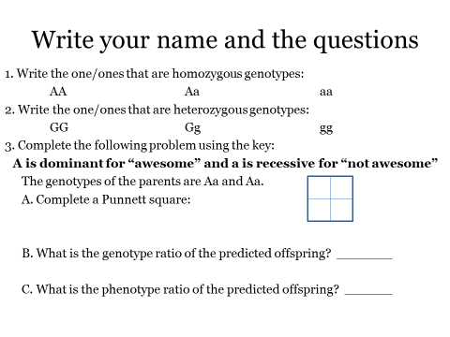
2) Mendel’s Laws (Cornell notes) page 5 (summarize)
3) Monohybrid crosses (p.6)

Friday January 24, 2020
Living Earth: Week 2 Day 99

BALLARD IN CLASSES (15 min)
Standard: Genetics
Learning Target: Practice determining the probability of single traits.

Essential Questions: How are traits passed down from parents to offspring?
Agenda:
1) Monohybrid crosses (p.6)

Monday January 27, 2020
Living Earth: Week 3 Day 100

Standard: Genetics
Learning Target: Revise Cornell notes to aid studying and practice differentiating between heterozygous and homozygous traits.

Essential Questions: How are traits passed down from parents to offspring?
Agenda:
1) Check notebook scores and StudentVue
2) p. 5 (Highlight and underline vocab and laws)
3) Check p. 7 (Spongebob)
4) Superheroes

Tuesday January 28, 2020
Living Earth: Week 3 Day 101

Standard: Genetics
Learning Target: Practice differentiating between heterozygous and homozygous traits through creating a superhero. Watch a video and practice determining prediction for genotypes and phenotypes of two traits.

Essential Questions: How are traits passed down from parents to offspring?
Agenda:
1) Finish Superheroes
2) Amoeba Sisters (Dihybrids) (only pers. 4 and 5)

Wednesday January 29, 2020
Living Earth: Week 3 Day 102

Standard: Genetics
Learning Target: Watch a video and practice making predictions for genotypes and phenotypes of two traits using Punnett squares.

Essential Questions: How are traits passed down from parents to offspring?
Agenda:
1) Amoeba Sisters (Dihybrids) (only pers. 2 and 6)
2) Dihybrid questions (mice) page 8
3) Exit Ticket:

Thursday January 30, 2020
Living Earth: Week 3 Day 103

Standard: Genetics
Learning Target: Practice determining the probability of two traits using a dihybrid cross and practice predictions of non-Mendelian codominance problems.

Essential Questions: How can we predict what traits will be passed down from parents to offspring?
Agenda:
1) Dihybrid questions (mice) page 8 (finish)
2) Amoeba Sisters (blood types – codominance)
3) Codominance and Multiple Alleles worksheet (p. 9)

Friday January 31, 2020
Living Earth: Week 3 Day 104

Standard: Genetics
Learning Target: Practice predictions of non-Mendelian codominance and incomplete dominance problems. Write Cornell notes about sex-linked traits and pedigrees.

Essential Questions: How can we predict what traits will be passed down from parents to offspring?
Agenda:
1) Codominance and Multiple Alleles worksheet (p. 9)
2) Incomplete Dominance Problems (p. 9)
3) Sex-linked traits and pedigrees notes (p. 10)

Monday February 3, 2020
Living Earth: Week 4 Day 105

Standard: Genetics
Learning Target: Write Cornell notes about sex-linked traits and pedigrees.

Essential Questions: How can we predict what traits will be passed down from parents to offspring?
Agenda:
1) Sex-linked traits and pedigrees notes (p. 10)
2) Summary

Tuesday February 4, 2020
Living Earth: Week 4 Day 106

Standard: Genetics
Learning Target: Practice answering questions to review for the test, write Cornell notes about sex-linked traits and pedigrees and practice “pedigree problems” to determine probabilities within families.

Essential Questions: How can we predict what traits will be passed down from parents to offspring?
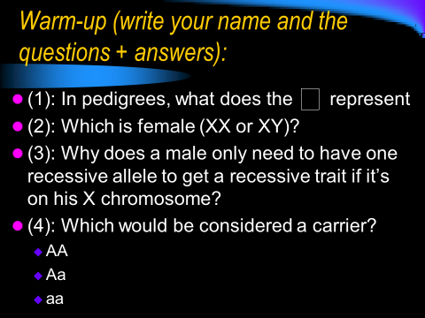
Agenda:
1) Test review warm-up:

2) Sex-linked traits and pedigrees notes (p. 10)
3) Summary (p. 10)
4) Pedigree problems (p. 11)

Wednesday February 5, 2020
Living Earth: Week 4 Day 107

Standard: Genetics
Learning Target: Practice “pedigree problems” to determine probabilities within families. Determine groups and topics for a project on genetic engineering.

Essential Questions: How can we predict what traits will be passed down from parents to offspring?
Agenda:
1) Review Pedigree problems (p. 11)
2) Genetic Engineering Projects (introduction):

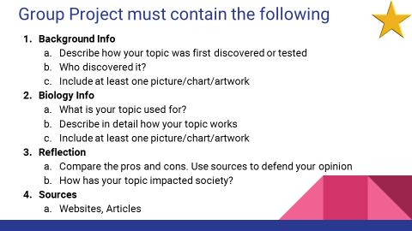

Thursday February 6, 2020
Living Earth: Week 4 Day 108
(Filming of Ms. Peru in periods 2 and 6)
Standard: Genetics
Learning Target: Research a real-world example of genetic engineering and communicate information to peers.

Essential Questions: How has genetic engineering impacted society?
Agenda:
1) Genetic Engineering Projects:

Friday February 7, 2020
Living Earth: Week 4 Day 109
Standard: Genetics
Learning Target: Research a real-world example of genetic engineering and communicate information to peers.

Essential Questions: How has genetic engineering impacted society?
Agenda:
1) Genetic Engineering Projects:

Monday February 10, 2020
Living Earth: Week 5 Day 110
COUNSELORS
Standard: Genetics
Learning Target: Learn about options for class selections for sophomore year. Review material for the genetics test.

Essential Questions: What classes should you choose for next year?
Agenda:
1) Counselors

Tuesday February 11, 2020
Living Earth: Week 5 Day 111
COUNSELORS
Standard: Genetics
Learning Target: Learn about options for class selections for sophomore year. Review material for the genetics test.

Essential Questions: What classes should you choose for next year?
Agenda:
1) Counselors

Wednesday February 12, 2020
Living Earth: Week 5 Day 112
Standard: Genetics
Learning Target: Review material for the genetics test.

Essential Questions: Are you ready for the test?
Agenda:
1) “Fly Swatter Review”

Thursday February 13, 2020
Living Earth: Week 5 Day 113
Standard: Genetics
Learning Target: Demonstrate understanding of genetics concepts by scoring well on a test.

Essential Questions: Did you study?
Agenda:
1) Genetics Test (turn in notebooks)

Tuesday February 18, 2020
Living Earth: Week 6 Day 114
Standard: Genetics
Learning Target: Create a slideshow, video, blog etc. to explain a use of genetic engineering to peers citing reliable sources.

Essential Questions: What are current examples of genetic engineering?
Agenda:
1) Finish Genetic Engineering Projects
2) P. 12 (Project notes)

Wednesday February 19, 2020
Living Earth: Week 6 Day 115
Standard: Genetics
Learning Target: Create a slideshow, video, blog etc. to explain a use of genetic engineering to peers citing reliable sources.

Essential Questions: What are current examples of genetic engineering?
Agenda:
1) Presentations

Thursday February 20, 2020
Living Earth: Week 6 Day 116
Standard: Genetics
Learning Target: Create a slideshow, video, blog etc. to explain a use of genetic engineering to peers citing reliable sources.

Essential Questions: What are current examples of genetic engineering?
Agenda:
1) Presentations

Friday February 21, 2020
Living Earth: Week 6 Day 117
Standard: Genetics
Learning Target: Read an article and consider ethical implications of using the cells of Henrietta Lacks without her knowledge.

Essential Questions: What are the ethical implications of using someone’s cells without their knowledge?
Agenda:
1) Henrietta Lack’s Article (p. 14)
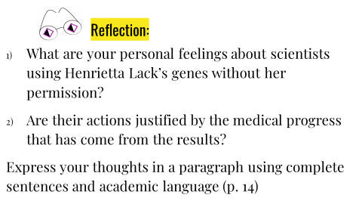
2) Reflection:

Monday February 24, 2020
Living Earth: Week 7 Day 118
Standard: Cells to Organisms
Learning Target: Read information about prokaryotic and eukaryotic cells and use a Foldable to compare and contrast the different cell types.

Essential Questions: What are similarities and differences of prokaryotic and eukaryotic cells?
Agenda:
1) Mark article (color code differences between prokaryotes, eukaryotes)
2) Set up foldable (see Google Classroom)

Tuesday February 25, 2020
Living Earth: Week 7 Day 119
Standard: Cells to Organisms
Learning Target: Read information about prokaryotic and eukaryotic cells and use a Foldable to compare and contrast the different cell types. Write a summary.

Essential Questions: What are similarities and differences of prokaryotic and eukaryotic cells?
Agenda:
1) Finish foldable (see Google Classroom) – page 15
2) Summarize (p. 15)
3) Amoeba Sisters “Plasma membrane”
4) “Bubble Lab” intro

Wednesday February 26, 2020
Living Earth: Week 7 Day 120
Standard: Cells to Organisms
Learning Target: Model the cell membrane using bubble solution and summarize each analog.

Essential Questions: What is the function of the cell membrane?
Agenda:
1) Cell Membrane “Bubble” Lab

Thursday February 27, 2020
Living Earth: Week 7 Day 121
Standard: Cells to Organisms
Learning Target: Explain how different cell types are made from stem cells if they all have the same DNA.

Essential Questions: How is our body made up of different cell types if they all have the same DNA?
Agenda:
1) Cell Diversity Warm-up
2) Cell Diversity Slide Show (make it)?

Friday February 28, 2020
Living Earth: Week 7 Day 122
Standard: Cells to Organisms
Learning Target: Explain how different cell types are made from stem cells if they all have the same DNA.

Essential Questions: How is our body made up of different cell types if they all have the same DNA?
Agenda:
1) Finish slideshows
2) Share out!

Monday March 2, 2020
Living Earth: Week 8 Day 123
Standard: Cells to Organisms
Learning Target: Extract your own DNA and understand that cells (including cheek cells) each have 6 feet of DNA inside the nucleus.

Essential Questions: How is DNA packaged in cells?
Agenda:
1) “DNA doesn’t look like what you think” video clip
2) DNA Extraction
3) Lab Write-up

Tuesday March 3, 2020
Living Earth: Week 8 Day 124
Standard: Cells to Organisms
Learning Target: Write definitions in your own words and find pictures online to add to a vocabulary matrix in order to get familiar with terms involved in Protein Synthesis.

Essential Questions: How are proteins made?
Agenda:
1) Protein Synthesis Vocabulary Matrix (Google Classroom)

Wednesday March 4, 2020
Living Earth: Week 8 Day 125
Standard: Cells to Organisms
Learning Target: Write key facts from a PowerPoint on Protein Synthesis.

Essential Questions: How are proteins made?
Agenda:
1) Protein Synthesis PowerPoint (p. 16)

Thursday March 5, 2020
Living Earth: Week 8 Day 126
Standard: Cells to Organisms
Learning Target: Model Protein Synthesis by using base pair rules to transcribe and translate.

Essential Questions: How are proteins made?
Agenda:
1) Protein Synthesis “Secret Code” activity
2) Gregorio clip
3) Reverse Transcription Practice (p. 17)
4) Protein Synthesis Clip and summary (p. 17)

Friday March 6, 2020
Living Earth: Week 8 Day 127
Sub Day – Field Trip
Standard: Cells to Organisms
Learning Target: Students will watch a video on growth and write key facts..

Essential Questions: How do humans grow?
Agenda:
1) “Amazing Human Body” Growth episode

Monday March 9, 2020
Living Earth: Week 9 Day 128

Standard: Cells to Organisms
Learning Target: Students will practice determining amino acids using an mRNA codon chart and will complete a thinking map about protein synthesis.

Essential Questions: How are proteins made from the DNA recipe?
Agenda:
1) Finish p. 17 (Reverse Transcription)
2) mRNA codon chart (p. 18)
3) Make groups for project

Tuesday March 10, 2020
Living Earth: Week 9 Day 129

Standard: Cells to Organisms
Learning Target: Students will practice protein synthesis while following a simulation and will model protein synthesis using paper pieces.

Essential Questions: How are proteins made from the DNA recipe?
Agenda:
1) Simulation (https://learn.genetics.utah.edu/content/basics/txtl/)
2) Performance Task (protein – step 1)

Wednesday March 11, 2020
Living Earth: Week 9 Day 130

Standard: Cells to Organisms
Learning Target: Students will model protein synthesis using paper pieces.

Essential Questions: How are proteins made from the DNA recipe?
Agenda:
1) Performance Task (protein – step 1)
2) Step 2: mRNA

