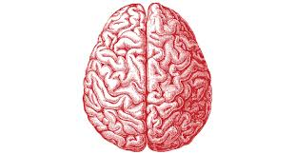
Brain WebQuest Name__________________________________ Per. ____

I. http://science.nationalgeographic.com/science/health-and-human-body/human-body/brain-article.html
Read the introduction article first.
Then answer the questions:
- What two macromolecules is the brain comprised of? ___________________________________________________________________
- What is the function of neurons (brain cells)? ___________________________________________________________________
- What part of the brain is more developed in humans than in other mammals? ______________
- What is the function of the hypothalamus? ___________________________________________________________________
- What do some of the hormones secreted by the pituitary affect? ___________________________________________________________________
- Why does the brainstem need extra protection? ______________________________________________________________________________________________________________________________________

- Click on the “brain anatomy” tab and complete the following:
- Based on the function of the frontal lobe, what is one possible outcome of a frontal lobe injury?
___________________________________________________________________
- Which section of the brain processes sounds (hearing)? ______________________________

Switch to the interior view (tab on bottom left):
- Which gland regulates sleep? ________________________________
- Draw and label the neuron:

“Stimulate the neuron:”
- Draw an arrow in your picture above to represent the direction that the electrochemical signal travels.
Click on “Stimulate the brain” and press on the different stimulations.
- List two “stimulations” that activate the same portion of the brain and list the area of the brain affected. ____________________________________________________________

Click on “Unhealthy brain” and read the descriptions of each of the common ailments of the brain.
- What causes a stroke? ___________________________________________________________________
- What is one of the symptoms of a stroke? ______________________________________
- What are at least 2 of the symptoms that stroke, Alzheimer’s disease and brain tumors have in common: ____________________________________________________________
- Based on what you’ve read about brain functions, explain why you think there are similar symptoms between different brain ailments. _________________________________________________________________________________________________________________________________________________________________________________________________________
Re-read the “summary” paragraph under the “Control Center” title next to the picture on the introduction page:
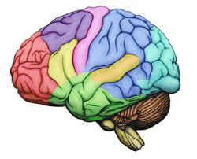
- If scientists don’t know everything about the brain, what is something that you think (or that you hope) they may figure out in the future? ___________________________________________________________________________________________________________________________________________________________________________________________________________________________________________________________________________________________________________________________________________________________________

