Monday January 13, 2020
APES: Week 1 Day 91

Standard: Chapter 11
Learning Target: Understand the benefits of biodiversity, the threats to biodiversity and possible methods to protect biodiversity.

Essential Questions: Why is biodiversity important?
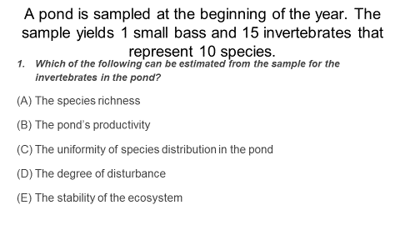
Agenda:
1) Biodiversity Practice Questions
2) Ch. 11 PPT

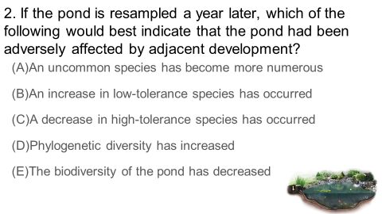

Tuesday January 14, 2020
APES: Week 1 Day 92

Standard: Chapter 11
Learning Target: Understand the benefits of biodiversity, the threats to biodiversity and possible methods to protect biodiversity.

Essential Questions: Why is biodiversity important?
Agenda:
1) Biodiversity Practice Questions
2) Schedule AP reviews
3) Ch. 11 PPT
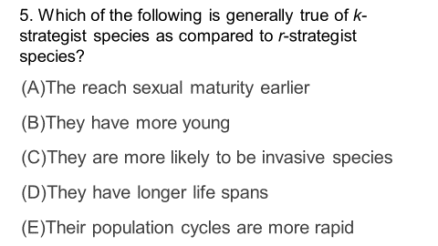
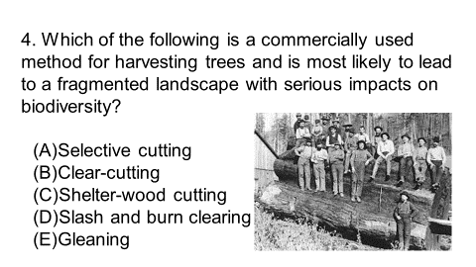

Wednesday January 15, 2020
APES: Week 1 Day 93

Standard: Chapter 11
Learning Target: Understand the benefits of biodiversity, the threats to biodiversity and possible methods to protect biodiversity.

Essential Questions: Why is biodiversity important?
Agenda:
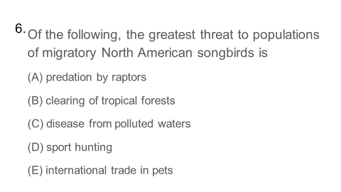
1) Biodiversity Practice Questions:
2) Ch. 11 PPT

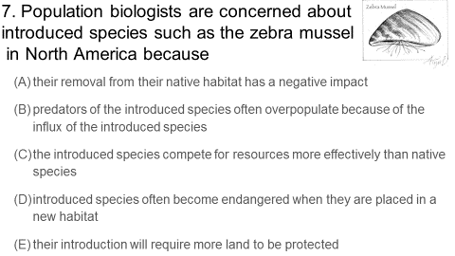

Thursday January 16, 2020
APES: Week 1 Day 94

Standard: Chapter 11
Learning Target: Understand the benefits of biodiversity, the threats to biodiversity and possible methods to protect biodiversity.

Essential Questions: Why is biodiversity important?
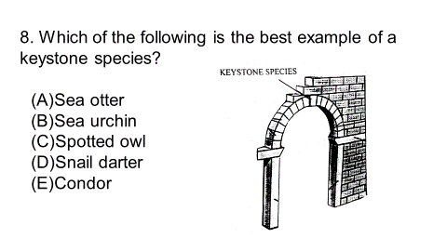
Agenda:
1) Biodiversity Practice Questions:
2) Ch. 11 PPT
3) FRQ (biodiversity)

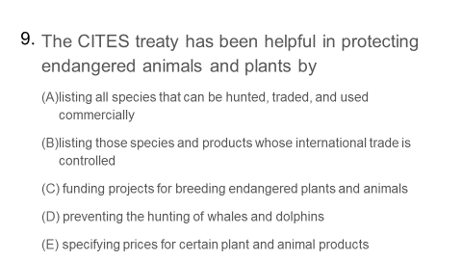

Friday January 17, 2020
APES: Week 1 Day 95

Standard: Chapter 11
Learning Target: Understand the benefits of biodiversity, the threats to biodiversity and possible methods to protect biodiversity.

Essential Questions: Why is biodiversity important?
Agenda:
1) Rank student writing samples
2) Score FRQ’s (annotate)

Tuesday January 21, 2020
APES: Week 2 Day 96

Standard: Chapter 12
Learning Target: Understand the factors necessary to plan land-use through creating a “rose” diagram and through discussing slides from chapter 12.

Essential Questions: What factors are necessary to plan land-use?
Agenda:
1) Rose Diagram
2) Ch. 12 PPT

Wednesday January 22, 2020
APES: Week 2 Day 97

Standard: Chapter 12
Learning Target: Understand the factors necessary to plan land-use through discussing slides from chapter 12.

Essential Questions: What factors are necessary to plan land-use?
Agenda:
1) Ch. 12 PPT

Thursday January 23, 2020
APES: Week 2 Day 98

Standard: Chapter 12
Learning Target: Demonstrate understanding of vocabulary related to land-use by scoring well on a quiz. Understand the factors necessary to plan land-use through discussing slides from chapter 12.

Essential Questions: What factors are necessary to plan land-use?
Agenda:
1) Ch. 12 Vocab Quiz
2) Ch. 12 PPT (start with video)

Friday January 24, 2020
APES: Week 2 Day 99

Standard: Chapter 12 (Land-use Planning)
Learning Target: Discuss land use planning and explore the Cathedral City Website to determine zoning etc.

Essential Questions: How should cities be designed?
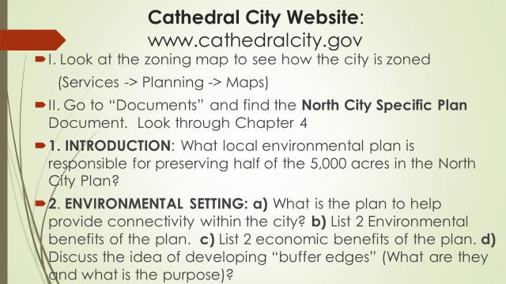
1)

2) Chapter 12 PPT

Monday January 27, 2020
APES: Week 3 Day 100

Standard: Chapter 12 (Land-use Planning)/Ch. 13 Soil
Learning Target: Discuss land-use planning and compare sand samples under the microscope to determine origin.

Essential Questions: How should cities be designed?
Agenda:
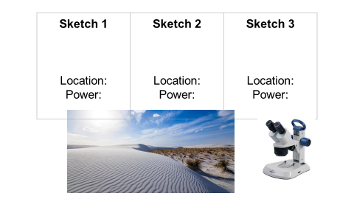
1) Ch. 12 PPT (finish)
2) Sand Lab:

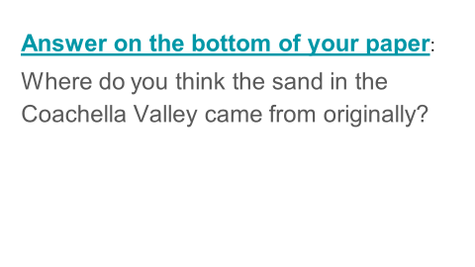

Tuesday January 28, 2020
APES: Week 3 Day 101

Standard: Chapter 12 (Land-use Planning)/Ch. 13 Soil
Learning Target: Discuss land-use planning and compare sand samples under the microscope to determine origin.

Essential Questions: How should cities be designed?
Agenda:
1) Panorama Survey

2) Sand Lab:

3) Ch. 13 PPT

Wednesday January 29, 2020
APES: Week 3 Day 102

Standard: Ch. 13 Soil
Learning Target: Answer review questions to determine prior knowledge and discuss slides about soil.

Essential Questions: How does soil form and why is it important?
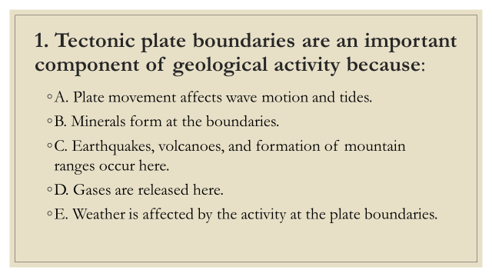
Agenda:
1) Practice questions
2) Ch. 13 PPT
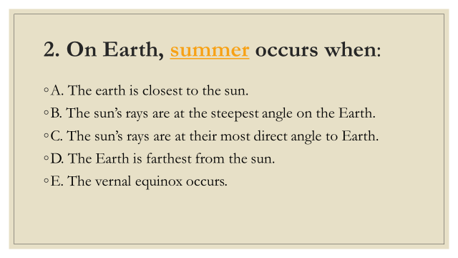
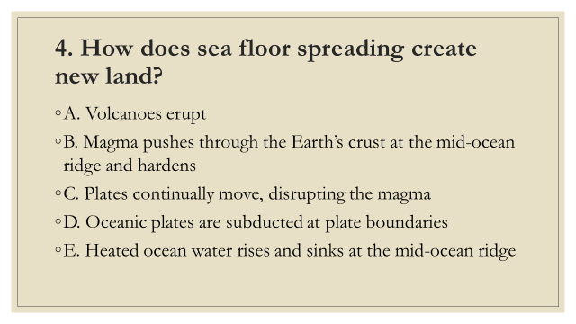

Thursday January 30, 2020
APES: Week 3 Day 103

Standard: Ch. 13 Soil
Learning Target: Answer review questions to determine prior knowledge and discuss slides about soil.

Essential Questions: How does soil form and why is it important?
Agenda:
1) Ch. 13 Vocab (Part 1)
2) Ch. 13 PPT

Friday January 31, 2020
APES: Week 3 Day 104

Standard: Ch. 13 Soil
Learning Target: Research plate boundaries and discuss slides about soil.

Essential Questions: How does soil form and why is it important?
Agenda:
1) Plate Boundaries (assignment)
2) Ch. 13 PPT

Monday February 3, 2020
APES: Week 4 Day 105

Standard: Ch. 13 Soil
Learning Target: Answer review questions about soil, discuss information (slides) about soil and its management and write key information about plant nutrients to prepare for a lab.

Essential Questions: How does soil form and why is it important?
Agenda:
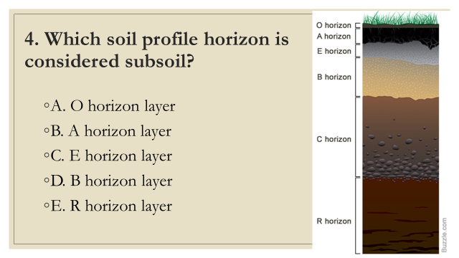
1) Review questions:

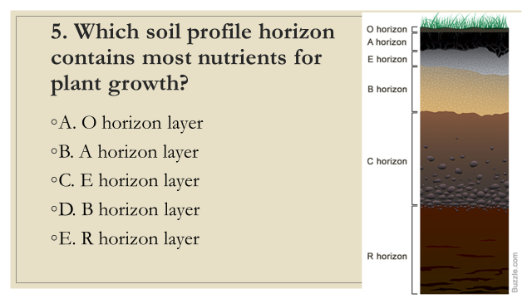
2) Ch. 13 PPT
3) Plant nutrients (add to lab)

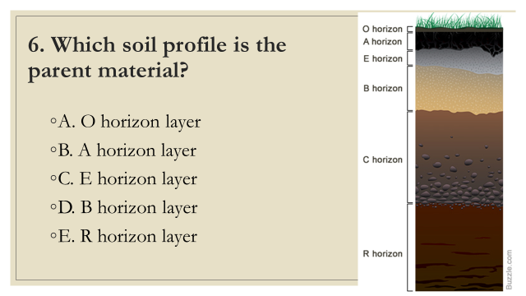

Tuesday February 4, 2020
APES: Week 4 Day 106

Standard: Ch. 13 Soil
Learning Target: Test soil samples for macronutrients and pH levels and discuss information (slides) about soil and its management.

Essential Questions: How does soil form and why is it important?
Agenda:
1) Soil testing (Soil Nutrients Lab)
2) Ch. 13 PPT

Wednesday February 5, 2020
APES: Week 4 Day 107

Standard: Ch. 13 Soil
Learning Target: Answer review questions and return papers.

Essential Questions: How does soil form and why is it important?
Agenda:
1) Return papers
2) Review questions (soil triangle)

Thursday February 6, 2020
APES: Week 4 Day 108

Standard: Ch. 13 Soil
Learning Target: Demonstrate understanding of soil vocabulary and agricultural methods to reduce erosion by scoring well on a quiz. Discuss soil conservation methods.

Essential Questions: How can soil be conserved?
Agenda:
1) Review questions (soil conservation methods)
2) Ch. 13 vocab (part 2)
3) Ch. 13 PPT

Friday February 7, 2020
APES: Week 4 Day 109

Standard: Ch. 13 Soil
Learning Target: Discuss soil conservation methods.

Essential Questions: How can soil be conserved?
Agenda:
1) Chapter 14 PPT
2) Green Revolution reading/study guide
3) Assign Salinization paragraphs

Monday February 10, 2020
APES: Week 5 Day 110

Standard: Ch. 14 Agriculture
Learning Target: Discuss salinization and agricultural methods.

Essential Questions: What is salinization?
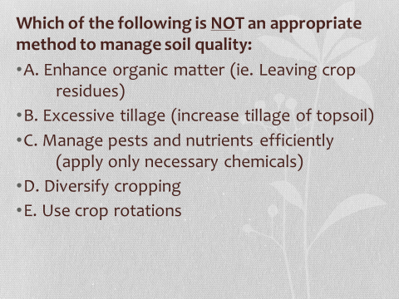
Agenda:
1) Review question:

2) Quick share-out (salinization paragraphs)
3) Ch. 14 PPT

Tuesday February 11, 2020
APES: Week 5 Day 111

Standard: Ch. 14 Agriculture
Learning Target: Practice test questions collaboratively by participating in a Kahoot! Discuss agricultural methods while looking over PowerPoint slides.

Essential Questions: What are different types of pesticides?
Agenda:
1) Ch. 14 PPT

Wednesday February 12, 2020
APES: Week 5 Day 112

Standard: Ch. 14 Agriculture
Learning Target: Practice test questions collaboratively by participating in a Kahoot! Discuss agricultural methods while looking over PowerPoint slides.

Essential Questions: What are different types of pesticides?
Agenda:
1) Kahoot (Ch. 13/14) Review 1
2) Ch. 14 PPT

Thursday February 13, 2020
APES: Week 5 Day 113

Standard: Ch. 14 Agriculture
Learning Target: Demonstrate understanding of agricultural vocabulary by scoring well on a quiz. Discuss agricultural methods while looking over PowerPoint slides.

Essential Questions: What are different types of pesticides?
Agenda:
1) Vocab Quiz Ch. 14
2) Ch. 14 PPT (to health part)

Tuesday February 18, 2020
APES: Week 6 Day 114

Standard: Ch. 14 Agriculture
Learning Target: Review agricultural related ideas by answering questions and watching video clips, Discuss the environment and human health issues.

Essential Questions: What are human health related issues connected to the environment?
Agenda:
1) Ch. 14 Review questions

Wednesday February 19, 2020
APES: Week 6 Day 115

Standard: Ch. 14 Agriculture
Learning Target: Review agricultural related ideas by answering questions and watching video clips, Discuss the environment and human health issues.

Essential Questions: What are human health related issues connected to the environment?
Agenda:
1) Soil Kahoot! #2
2) Graphing practice (corn)
3) Ch. 14 (Health Info)

Thursday February 20, 2020
APES: Week 6 Day 116

Standard: Ch. 13/Ch. 14
Learning Target: Demonstrate understanding of soil and agriculture by scoring well on a test.

Essential Questions: Did you study?
Agenda:
1) Ch. 13/14 Test

Friday February 21, 2020
APES: Week 6 Day 117

Standard: Health
Learning Target: Understand how infectious diseases can spread through populations through brainstorming, discussing slides and watching video clips.

Essential Questions: How are diseases spread?
Agenda:
1) Health (End of Ch. 14 PPT)
2) Brainstorm types of water pollution
3) Ch. 15 PPT

Monday February 24, 2020
APES: Week 7 Day 118

Standard: Health
Learning Target: Understand how infectious diseases can spread through populations through brainstorming, discussing slides and watching video clips.

Essential Questions: How are diseases spread?
Agenda:
1) Return Papers/discuss tests
2) Health (End of Ch. 14 PPT)

Tuesday February 25, 2020
APES: Week 7 Day 119

Standard: Water
Learning Target: Brainstorm types of water pollution and discuss pollution sources and effects and organize information into a grid.

Essential Questions: What are common types of water pollution and their effects?
Agenda:
1) Brainstorm types of water pollution
2) Ch. 15 PPT (with grid)

Wednesday February 26, 2020
APES: Week 7 Day 120

Standard: Water
Learning Target: Model watersheds and discuss pollution sources and effects and organize information into a grid.

Essential Questions: What are watersheds? What are common types of water pollution and their effects?
Agenda:
1) Watershed activity
2) Ch. 15 PPT (with grid)

Thursday February 27, 2020
APES: Week 7 Day 121

Standard: Water
Learning Target: Model watersheds and discuss pollution sources and effects and organize information into a grid.

Essential Questions: What are common types of water pollution and their effects?
Agenda:
1) Brainstorm types of water pollution
2) Ch. 15 PPT

Friday February 28, 2020
APES: Week 7 Day 122

Standard: Water
Learning Target: Demonstrate understanding of water management related vocabulary by scoring well on a quiz. Discuss pollution sources and effects and organize information into a grid.

Essential Questions: What are common types of water pollution and their effects?
Agenda:
1) Ch. 15 Vocab Quiz
2) Ch. 15 PPT

Monday March 2, 2020
APES: Week 8 Day 123

Standard: Water
Learning Target: Discuss Whitewater field trip and background to water monitoring. Discuss pollution sources and effects and organize information into a grid.

Essential Questions: What are common types of water pollution and their effects?
Agenda:
1) Whitewater Background info
2) Ch. 15 PPT

Tuesday March 3, 2020
APES: Week 8 Day 124

Standard: Water
Learning Target: Model water pollution and write a story distinguishing between point and nonpoint source pollution to explain the source of the pollution found.

Essential Questions: What is the difference between point source and nonpoint source pollution?
Agenda:
1) Water Pollution Lab

Wednesday March 4, 2020
APES: Week 8 Day 125

Standard: Water
Learning Target: Organize cut-outs into a tree-map explaining the stages of wastewater treatment. Discuss slides about water management.

Essential Questions: What are the different stages of wastewater treatment?
Agenda:
1) Wastewater treatment “tree” map
2) Ch. 15 PPT

Thursday March 5, 2020
APES: Week 8 Day 126

Standard: Water
Learning Target: Participate in a Water Kahoot! to practice for the chapter test. Discuss slides about water management.

Essential Questions: What are the different stages of wastewater treatment?
Agenda:
1) Water Kahoot!
2) Ch. 15 PPT

Friday March 6, 2020
APES: Week 8 Day 127

Standard: Water
Learning Target: Whitewater Field Trip. Collect macroinvertebrates to gauge water quality and complete other water quality testing.

Essential Questions: What are the different ways that water quality can be tested?
Agenda:
1) Whitewater

Monday March 9, 2020
APES: Week 9 Day 128

Standard: Water Management
Learning Target: Write a paragraph about eutrophication to practice for the test and answer review questions about water management.

Essential Questions: What are different causes and effects of water pollution?
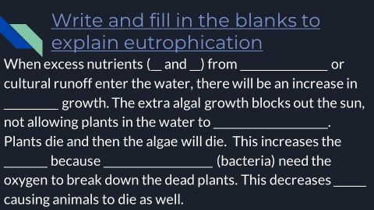
Agenda:
1) Eutrophication practice:

2) Ch. 15 Review Questions

Tuesday March 10, 2020
APES: Week 9 Day 129

Standard: Water Management
Learning Target: Answer review questions about water management. Sort different types of air pollution to match sources with descriptions. Correct the pairings using an air pollution review guide.

Essential Questions: What are different causes and effects of water pollution?
Agenda:
1) Finish Ch. 15 review questions
2) Sort air pollution sources and definitions
3) Correct sorting using a review guide

Wednesday March 11, 2020
APES: Week 9 Day 130

Standard: Water Management
Learning Target: Demonstrate understanding of water management by correctly answering exam questions and writing an explanation of eutrophication.

Essential Questions: What are different causes and effects of water pollution?
Agenda:
1) Ch. 15 Test

